# Sites that were included

NSAMDD0014 Test Set: (Timestamp('2017-10-01 00:00:00'), Timestamp('2020-01-27 00:00:00')), Period: 77  
  
NTADMR0001 Test Set: (Timestamp('2020-09-17 00:00:00'), Timestamp('2022-12-20 00:00:00')), Period: 89  
  
NTADMR0002 Test Set: (Timestamp('2008-08-15 00:00:00'), Timestamp('2011-08-23 00:00:00')), Period: 158  
  
NTAFIN0010 Test Set: (Timestamp('2004-02-10 00:00:00'), Timestamp('2006-11-22 00:00:00')), Period: 137  
  
NTAFIN0014 Test Set: (Timestamp('2009-02-06 00:00:00'), Timestamp('2012-12-08 00:00:00')), Period: 150  
  
NTAFIN0023 Test Set: (Timestamp('2006-12-08 00:00:00'), Timestamp('2009-10-05 00:00:00')), Period: 78  
  
NTAGFU0002 Test Set: (Timestamp('1992-11-16 00:00:00'), Timestamp('1998-09-14 00:00:00')), Period: 93  
  
NTAGFU0004 Test Set: (Timestamp('2015-06-09 00:00:00'), Timestamp('2017-12-15 00:00:00')), Period: 92  
  
NTAGFU0005 Test Set: (Timestamp('2003-09-20 00:00:00'), Timestamp('2006-04-13 00:00:00')), Period: 91  
  
NTAGFU0007 Test Set: (Timestamp('1987-09-16 00:00:00'), Timestamp('1993-03-08 00:00:00')), Period: 93  
  
NTAGFU0008 Test Set: (Timestamp('2020-01-14 00:00:00'), Timestamp('2022-12-21 00:00:00')), Period: 93  
  
NTAGFU0009 Test Set: (Timestamp('2012-06-08 00:00:00'), Timestamp('2015-04-06 00:00:00')), Period: 93  
  
NTAGFU0010 Test Set: (Timestamp('2006-03-20 00:00:00'), Timestamp('2008-12-06 00:00:00')), Period: 94  
  
NTAGFU0012 Test Set: (Timestamp('2011-12-15 00:00:00'), Timestamp('2014-12-31 00:00:00')), Period: 93  
  
NTAGFU0015 Test Set: (Timestamp('2003-10-22 00:00:00'), Timestamp('2006-05-07 00:00:00')), Period: 93  
  
NTAGFU0022 Test Set: (Timestamp('2017-12-14 00:00:00'), Timestamp('2020-04-26 00:00:00')), Period: 84  
  
NTAGFU0024 Test Set: (Timestamp('2006-10-13 00:00:00'), Timestamp('2009-07-09 00:00:00')), Period: 88  
  
NTAGFU0028 Test Set: (Timestamp('2020-06-21 00:00:00'), Timestamp('2022-12-12 00:00:00')), Period: 85  
  
NTAMGD0003 Test Set: (Timestamp('1987-09-14 00:00:00'), Timestamp('1993-11-01 00:00:00')), Period: 95  
  
NTASSD0001 Test Set: (Timestamp('2009-10-15 00:00:00'), Timestamp('2013-07-22 00:00:00')), Period: 96  
  
NTATAN0003 Test Set: (Timestamp('2012-02-15 00:00:00'), Timestamp('2015-04-21 00:00:00')), Period: 154  
  
NTATAN0004 Test Set: (Timestamp('2020-04-01 00:00:00'), Timestamp('2022-12-20 00:00:00')), Period: 158  
  
QDASSD0001 Test Set: (Timestamp('1999-08-10 00:00:00'), Timestamp('2004-02-21 00:00:00')), Period: 96  
  
QDASSD0002 Test Set: (Timestamp('1987-09-02 00:00:00'), Timestamp('1993-09-02 00:00:00')), Period: 95  
  
QDASSD0004 Test Set: (Timestamp('2013-01-04 00:00:00'), Timestamp('2015-07-21 00:00:00')), Period: 94  
  
QDASSD0008 Test Set: (Timestamp('1999-10-29 00:00:00'), Timestamp('2004-07-30 00:00:00')), Period: 101  
  
SATFLB0008 Test Set: (Timestamp('1999-05-07 00:00:00'), Timestamp('2004-01-21 00:00:00')), Period: 70  
  
SATFLB0018 Test Set: (Timestamp('1992-02-21 00:00:00'), Timestamp('1997-04-07 00:00:00')), Period: 145  
  
SATFLB0019 Test Set: (Timestamp('2005-06-01 00:00:00'), Timestamp('2008-01-25 00:00:00')), Period: 143  
  
SATFLB0021 Test Set: (Timestamp('1987-09-11 00:00:00'), Timestamp('1992-08-31 00:00:00')), Period: 149  
  
WAACEK0003 Test Set: (Timestamp('2003-05-23 00:00:00'), Timestamp('2005-12-06 00:00:00')), Period: 86  
  
WAACOO0031 Test Set: (Timestamp('2012-11-14 00:00:00'), Timestamp('2015-09-28 00:00:00')), Period: 78  
  
WAACOO0032 Test Set: (Timestamp('2009-05-30 00:00:00'), Timestamp('2012-10-13 00:00:00')), Period: 77  
  
WAAGSD0001 Test Set: (Timestamp('1993-12-11 00:00:00'), Timestamp('1999-05-18 00:00:00')), Period: 95  
  
WAALSD0003 Test Set: (Timestamp('2011-10-19 00:00:00'), Timestamp('2015-02-23 00:00:00')), Period: 164  
  
WAAMUR0001 Test Set: (Timestamp('2008-12-29 00:00:00'), Timestamp('2012-06-07 00:00:00')), Period: 85  
  
WAAMUR0002 Test Set: (Timestamp('2020-05-04 00:00:00'), Timestamp('2022-12-28 00:00:00')), Period: 85  
  
WAAMUR0028 Test Set: (Timestamp('2015-05-31 00:00:00'), Timestamp('2017-12-22 00:00:00')), Period: 89  
  
WAAMUR0029 Test Set: (Timestamp('1993-10-17 00:00:00'), Timestamp('1999-08-15 00:00:00')), Period: 90  
  
WAAMUR0030 Test Set: (Timestamp('2006-07-09 00:00:00'), Timestamp('2009-04-04 00:00:00')), Period: 91  
  
WAAMUR0031 Test Set: (Timestamp('2015-05-31 00:00:00'), Timestamp('2017-12-14 00:00:00')), Period: 90  
  
WAAPIL0002 Test Set: (Timestamp('2003-07-30 00:00:00'), Timestamp('2006-05-11 00:00:00')), Period: 96  
  
WAAPIL0003 Test Set: (Timestamp('2018-09-17 00:00:00'), Timestamp('2020-07-28 00:00:00')), Period: 101  
  
WAAPIL0006 Test Set: (Timestamp('2020-08-05 00:00:00'), Timestamp('2022-12-25 00:00:00')), Period: 98  
  
WAAPIL0012 Test Set: (Timestamp('2016-07-02 00:00:00'), Timestamp('2018-07-31 00:00:00')), Period: 124  
  
WAAPIL0013 Test Set: (Timestamp('2016-04-29 00:00:00'), Timestamp('2018-05-29 00:00:00')), Period: 143  
  
WAAPIL0017 Test Set: (Timestamp('1998-10-13 00:00:00'), Timestamp('2003-08-24 00:00:00')), Period: 92  
  
WAAPIL0020 Test Set: (Timestamp('2018-02-21 00:00:00'), Timestamp('2020-07-12 00:00:00')), Period: 94  
  
WAAPIL0027 Test Set: (Timestamp('1998-08-10 00:00:00'), Timestamp('2002-12-03 00:00:00')), Period: 166  
  
WAAPIL0031 Test Set: (Timestamp('2006-02-13 00:00:00'), Timestamp('2009-01-04 00:00:00')), Period: 90  
  
WAAPIL0034 Test Set: (Timestamp('1987-09-06 00:00:00'), Timestamp('1993-10-08 00:00:00')), Period: 94  
  
WAAPIL0035 Test Set: (Timestamp('2017-11-11 00:00:00'), Timestamp('2020-03-24 00:00:00')), Period: 93  
  
WAAVIB0002 Test Set: (Timestamp('2015-07-05 00:00:00'), Timestamp('2017-12-25 00:00:00')), Period: 89  
  
WAGCOO0002 Test Set: (Timestamp('1992-07-26 00:00:00'), Timestamp('1998-10-31 00:00:00')), Period: 137

# Table: MSE of the Random Forest on each output

|  |  |  |  |  |
| --- | --- | --- | --- | --- |
|  | pv_filter | npv_filter | bs_filter | loss_mean |
| Train | 0.449 | 0.766 | 1.011 | 0.742 |
| Test | 17.703 | 53.791 | 68.822 | 46.772 |

# Permutation Importance

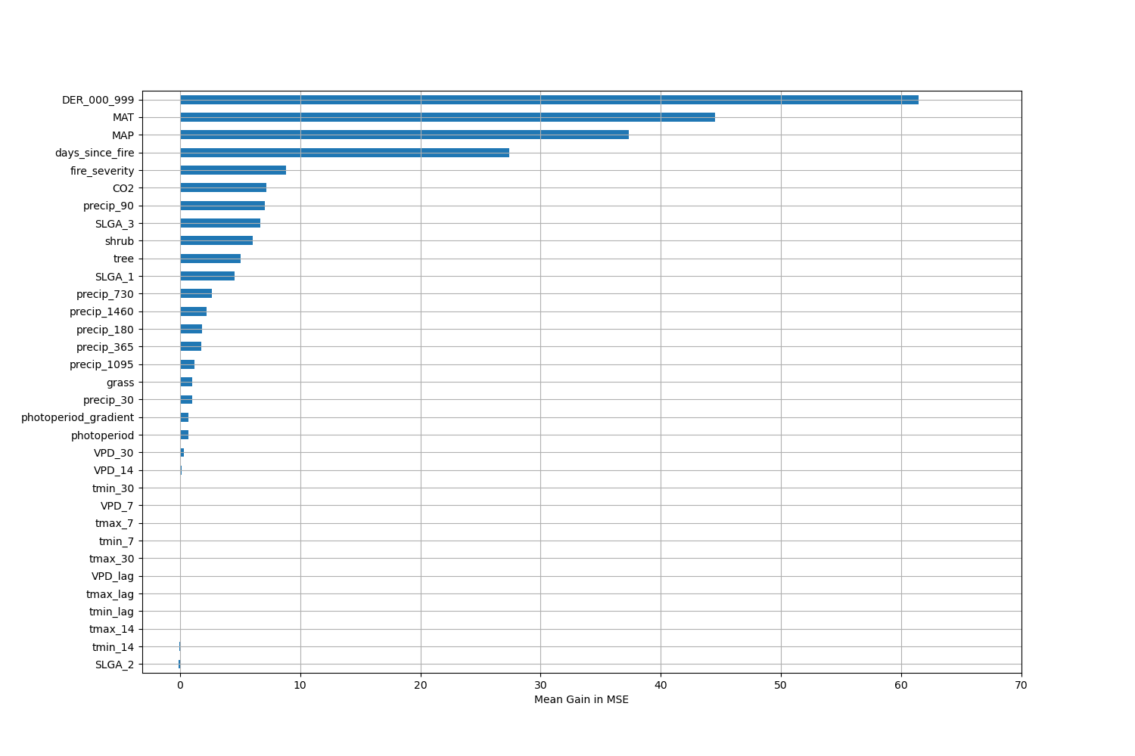

# Permutation Importance by Precip

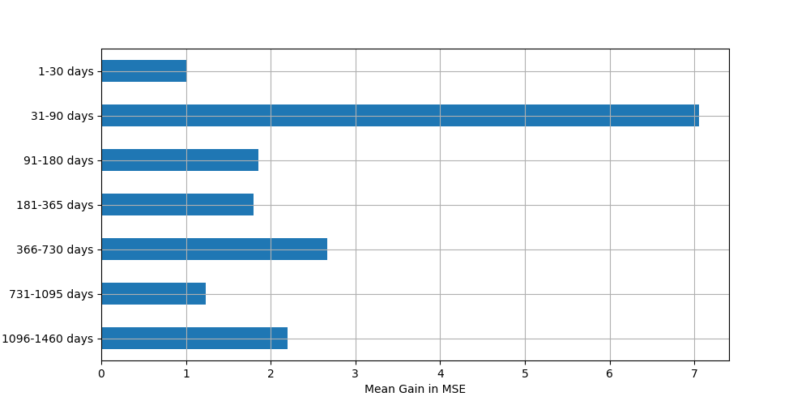

# ALE Importance

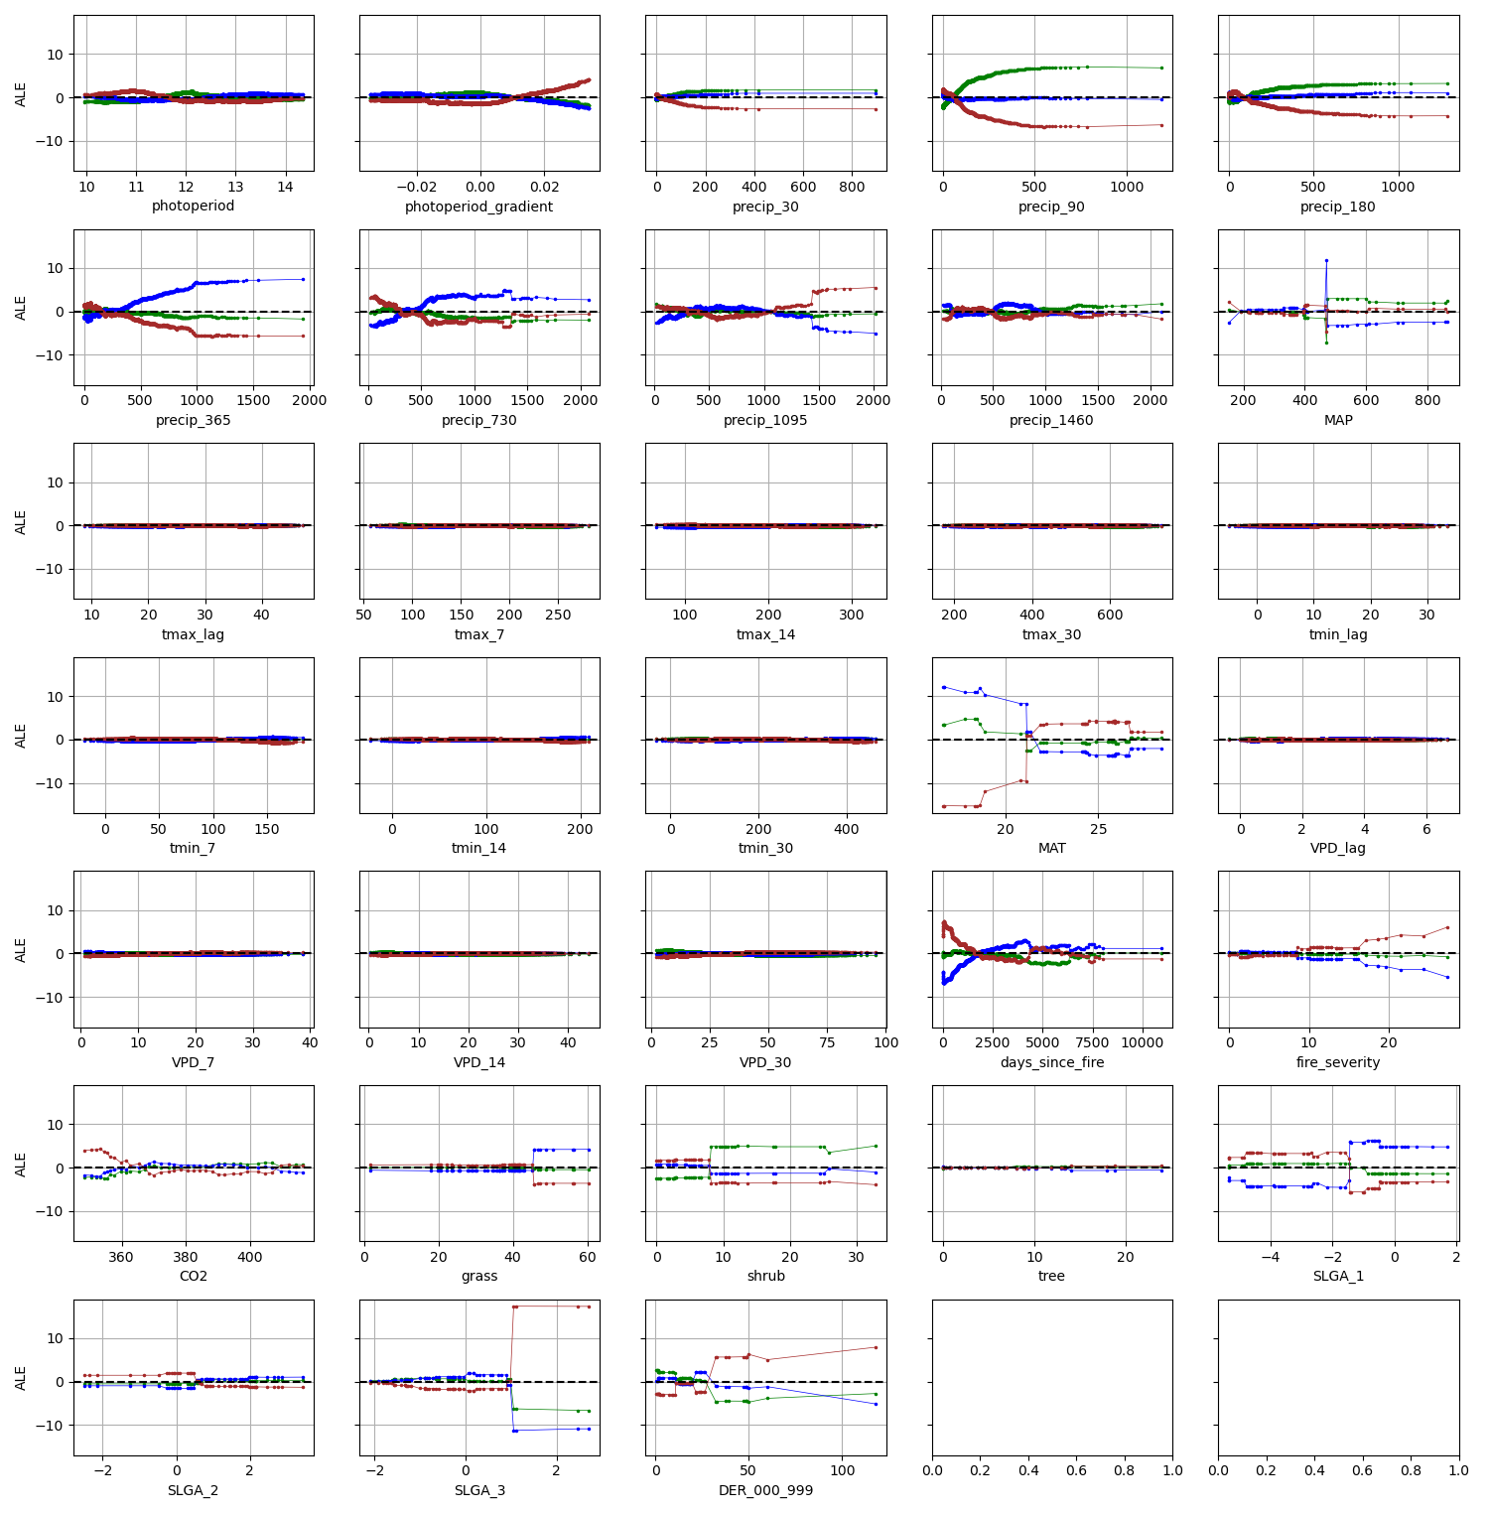

# NSAMDD0014

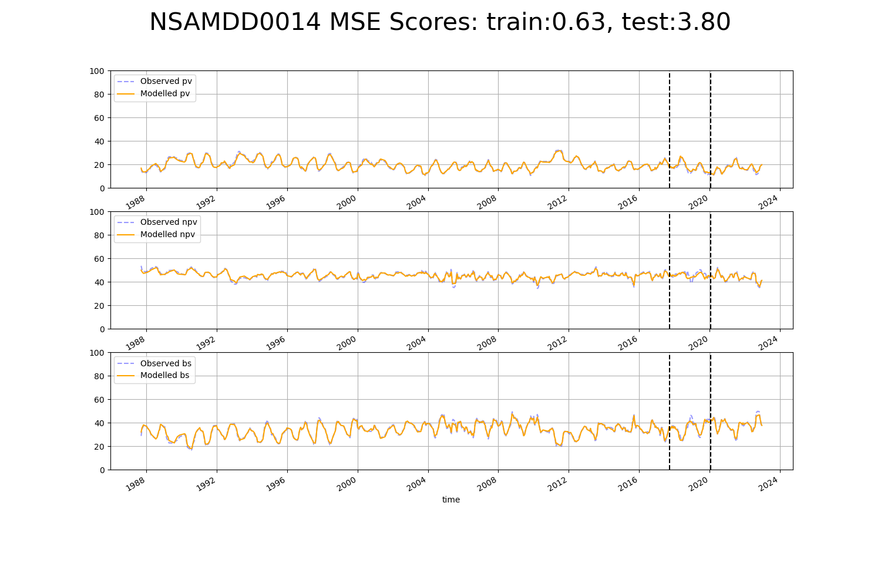

# NTADMR0001

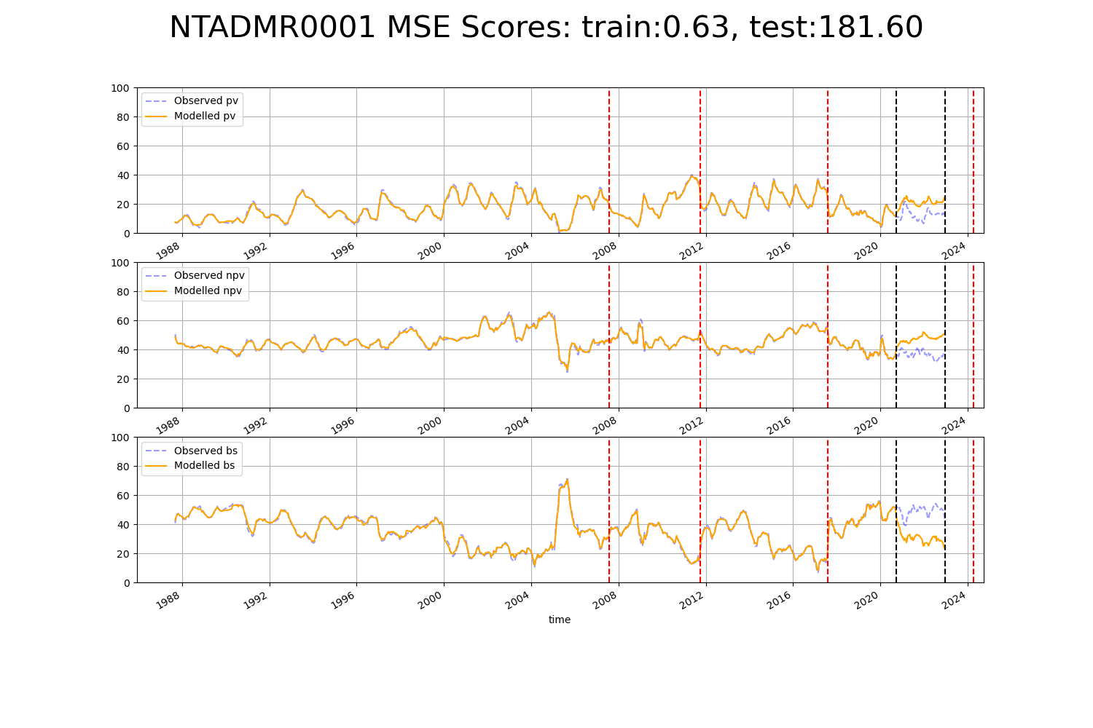

# NTADMR0002

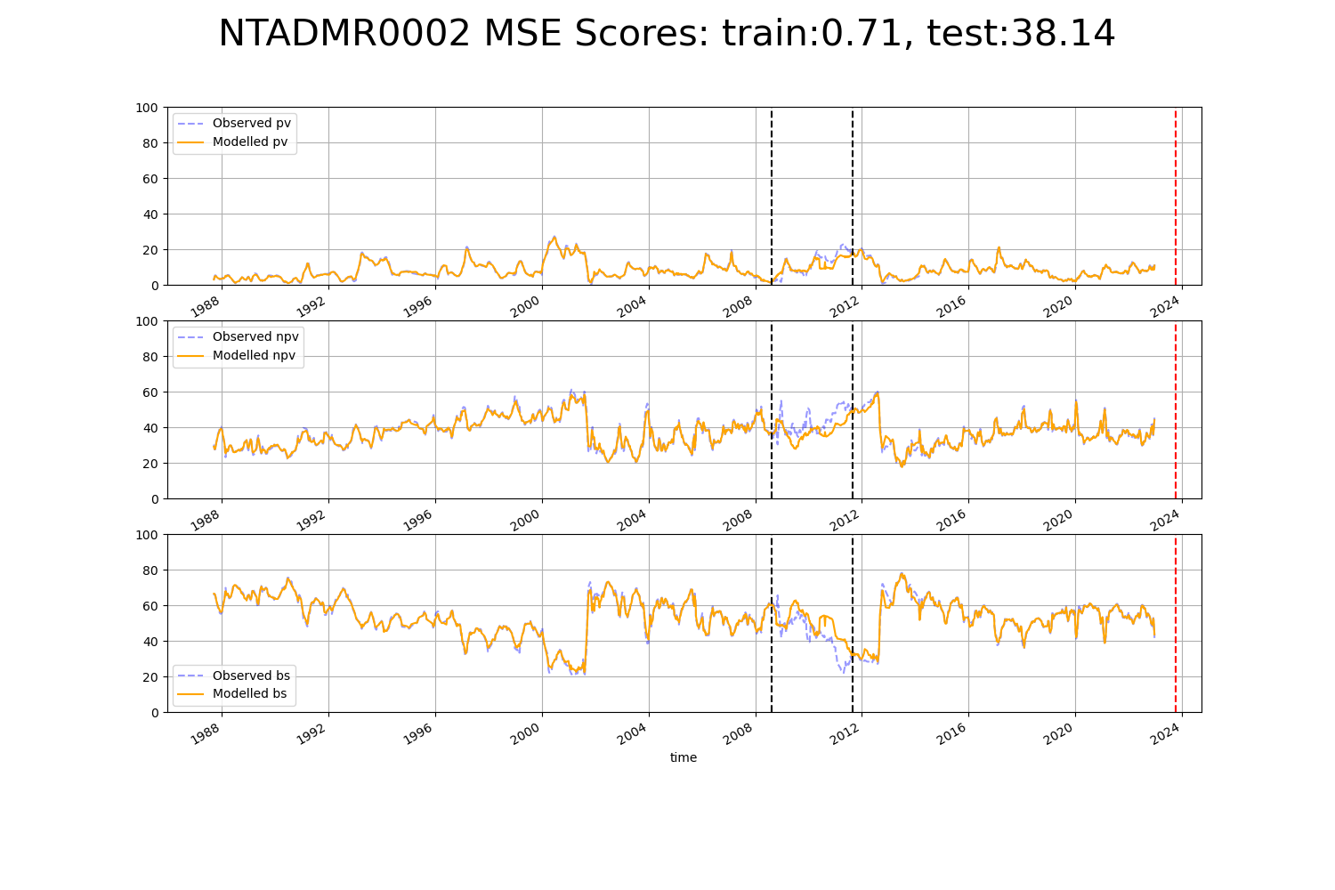

# NTAFIN0010

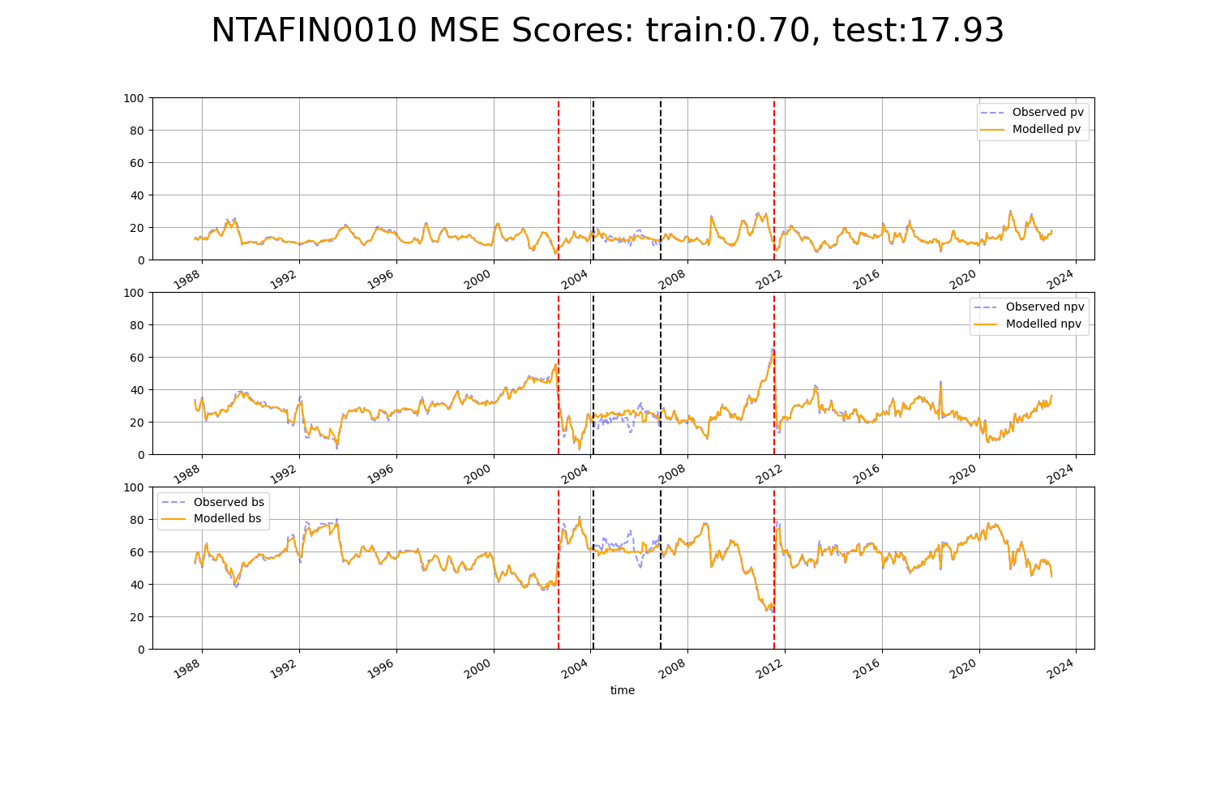

# NTAFIN0014

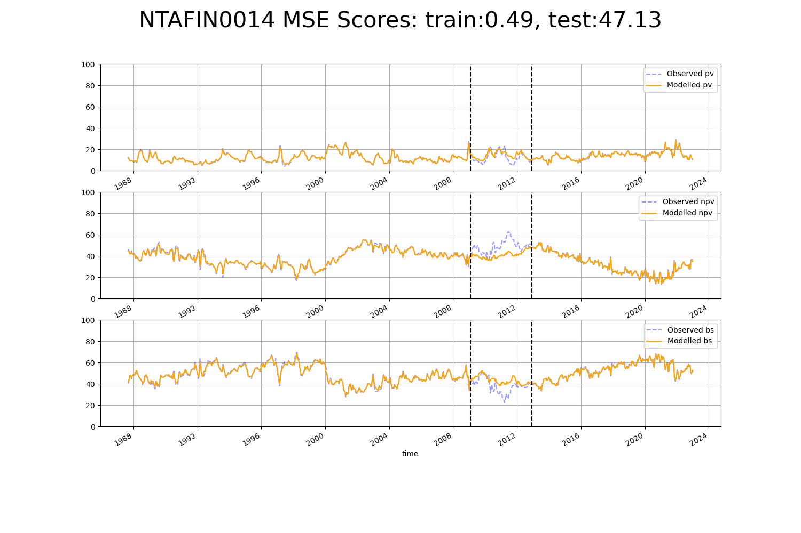

# NTAFIN0023

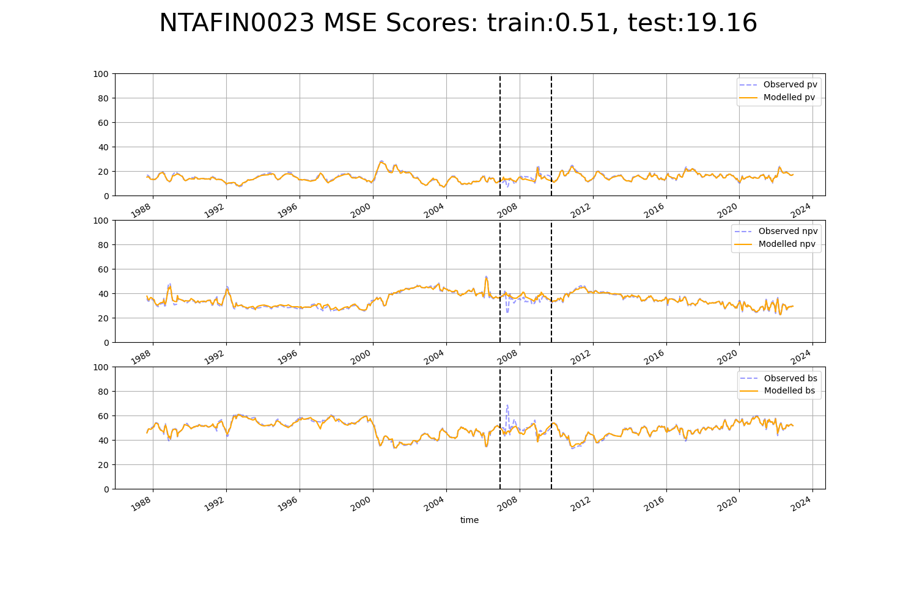

# NTAGFU0002

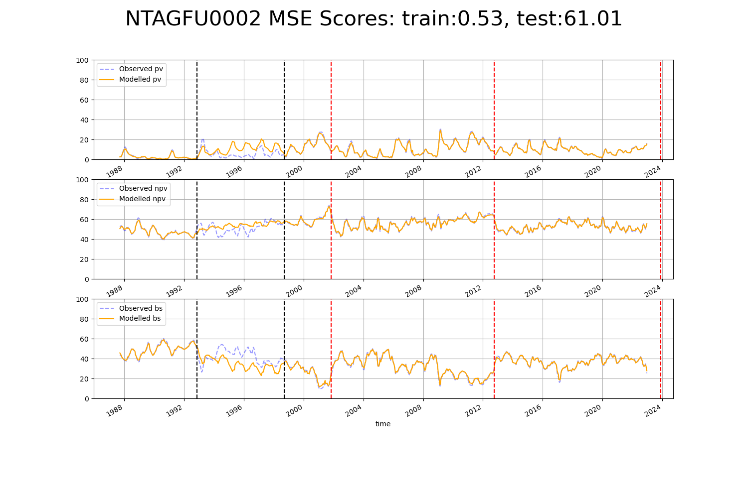

# NTAGFU0004

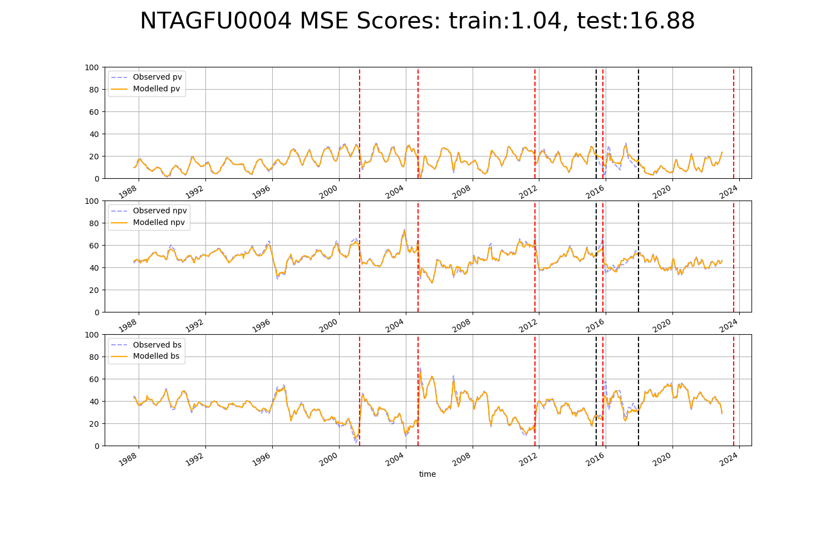

# NTAGFU0005

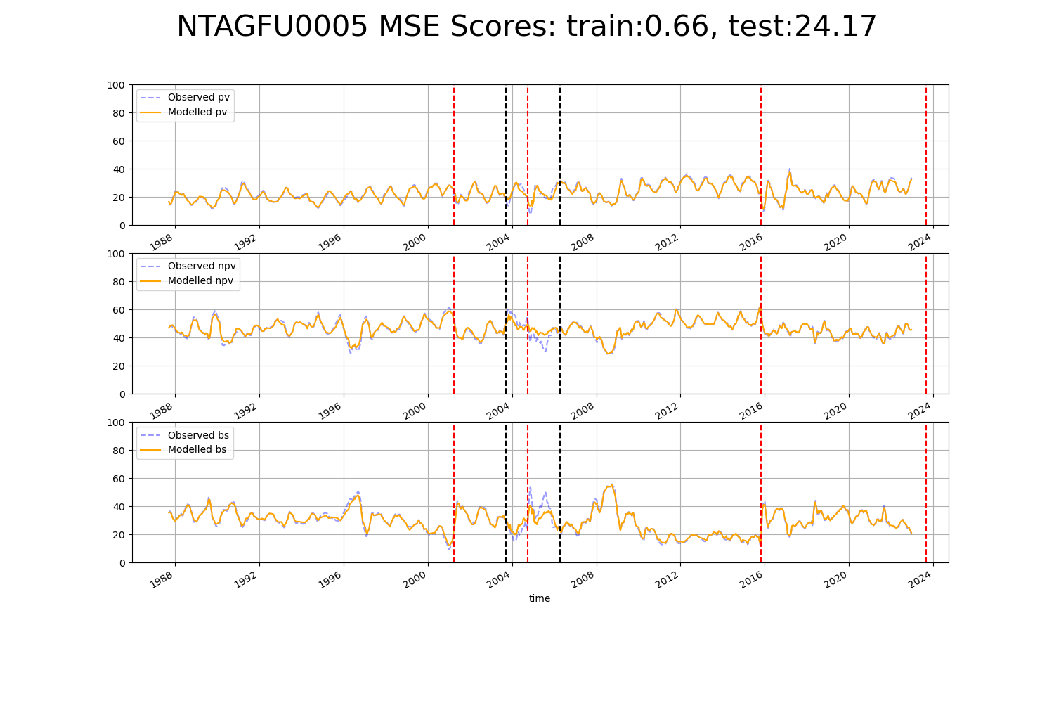

# NTAGFU0007

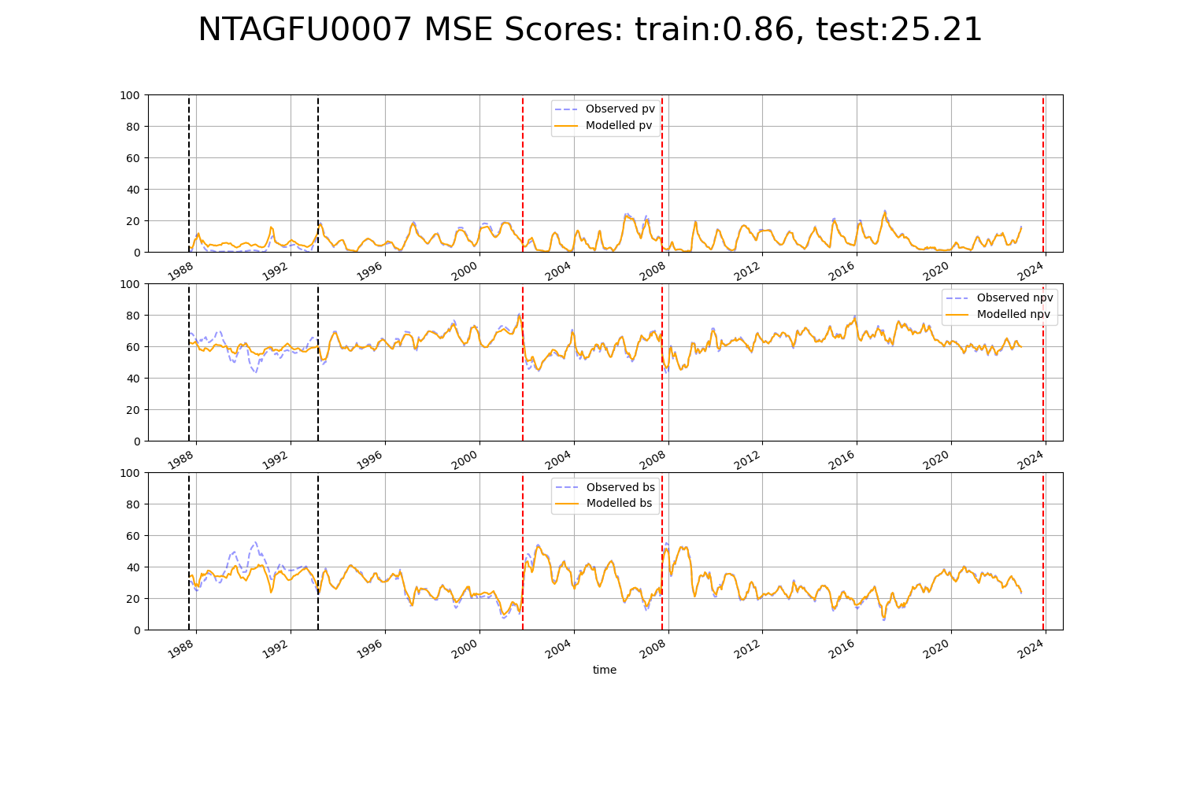

# NTAGFU0008

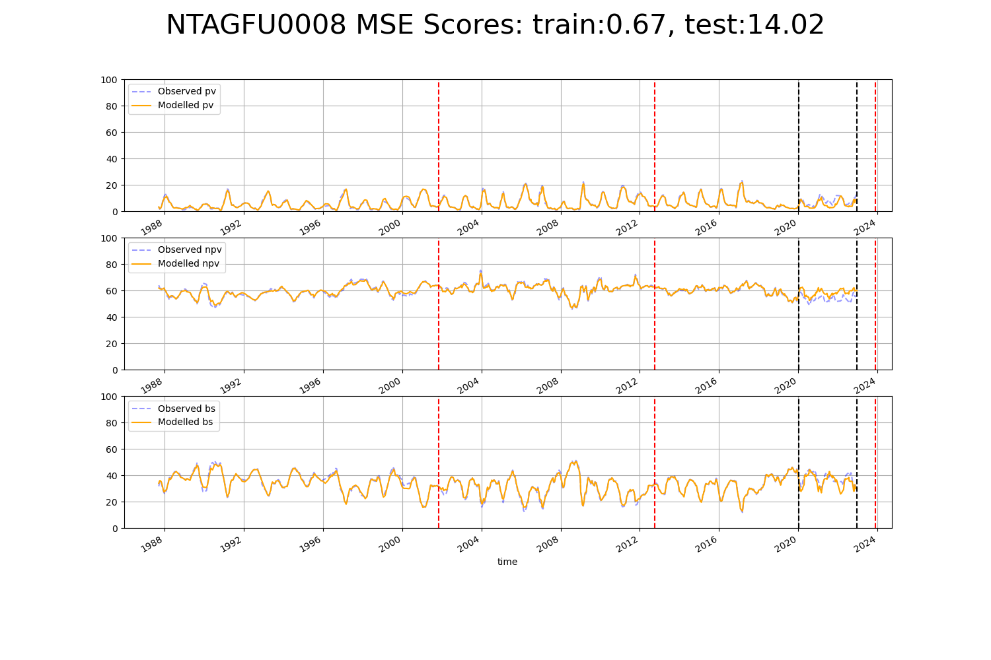

# NTAGFU0009

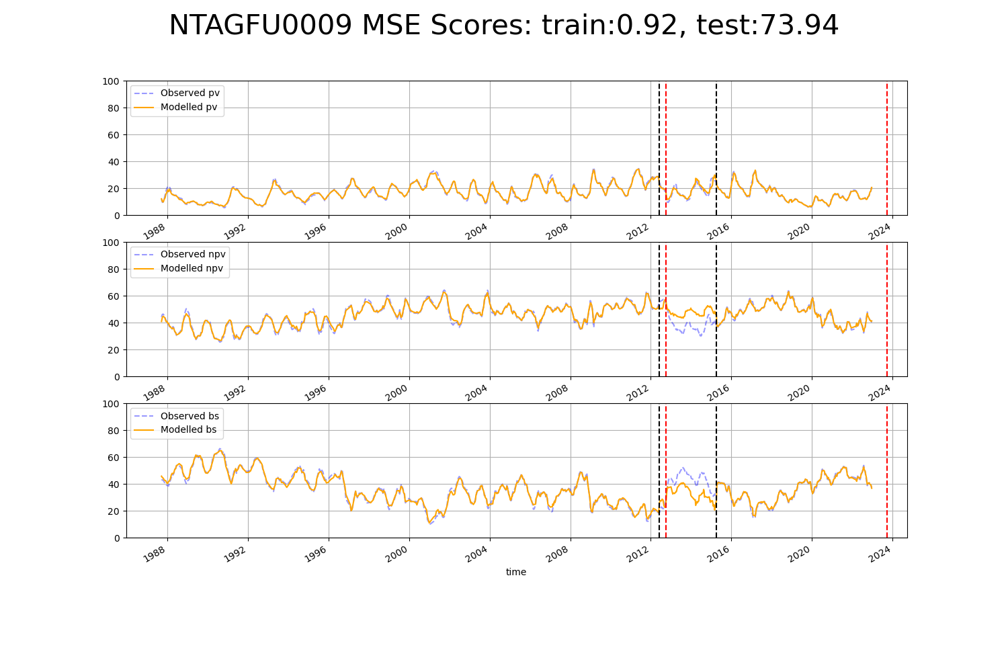

# NTAGFU0010

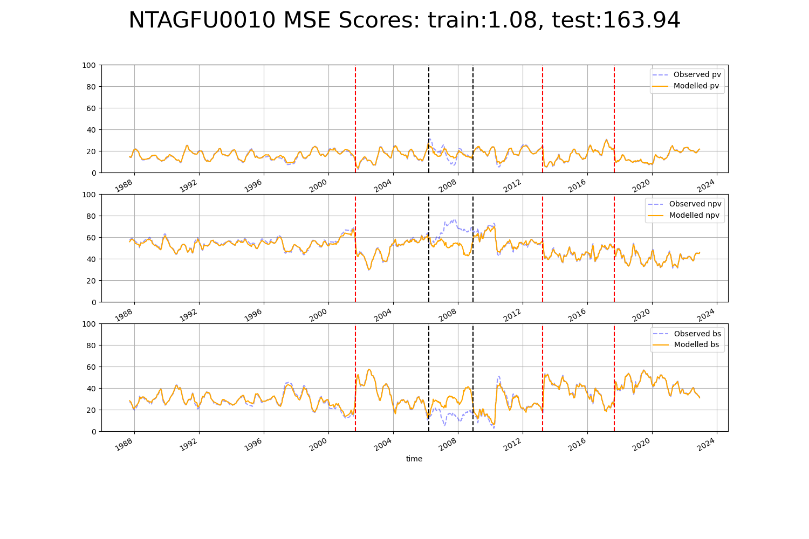

# NTAGFU0012

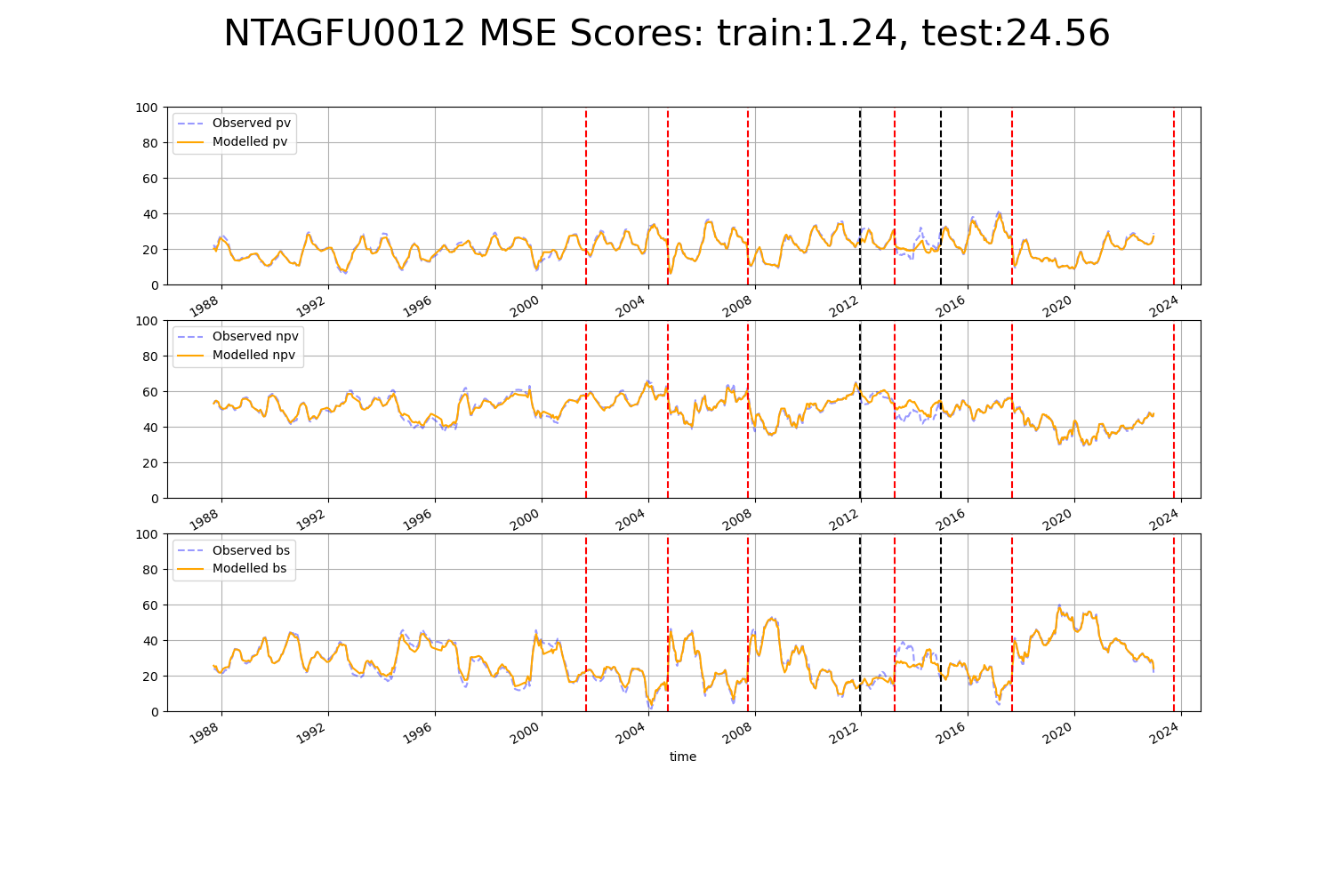

# NTAGFU0015

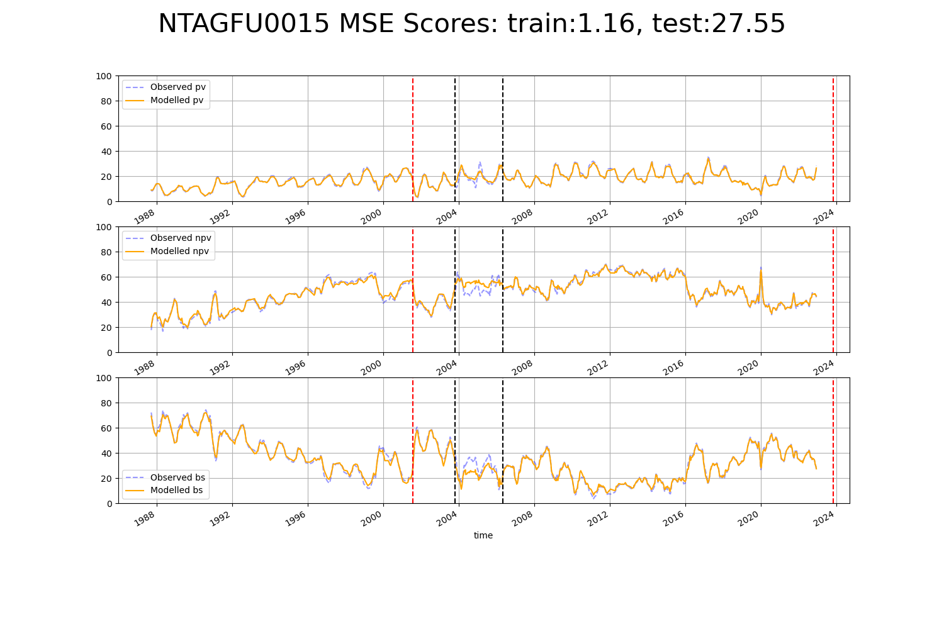

# NTAGFU0022

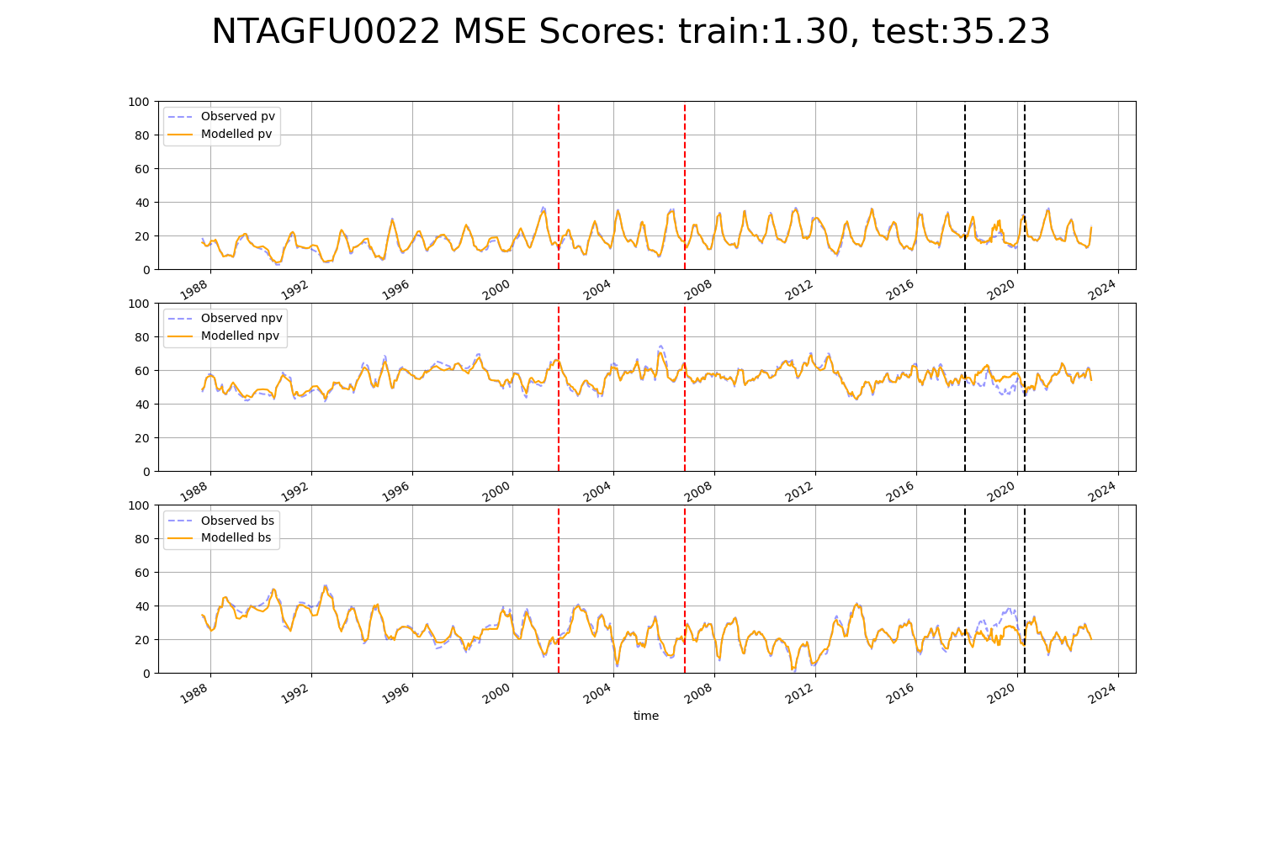

# NTAGFU0024

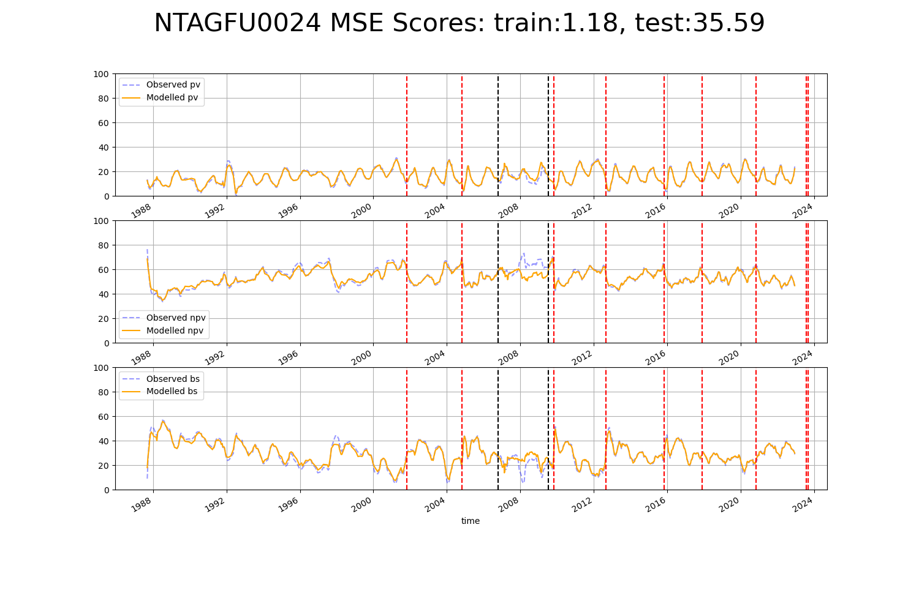

# NTAGFU0028

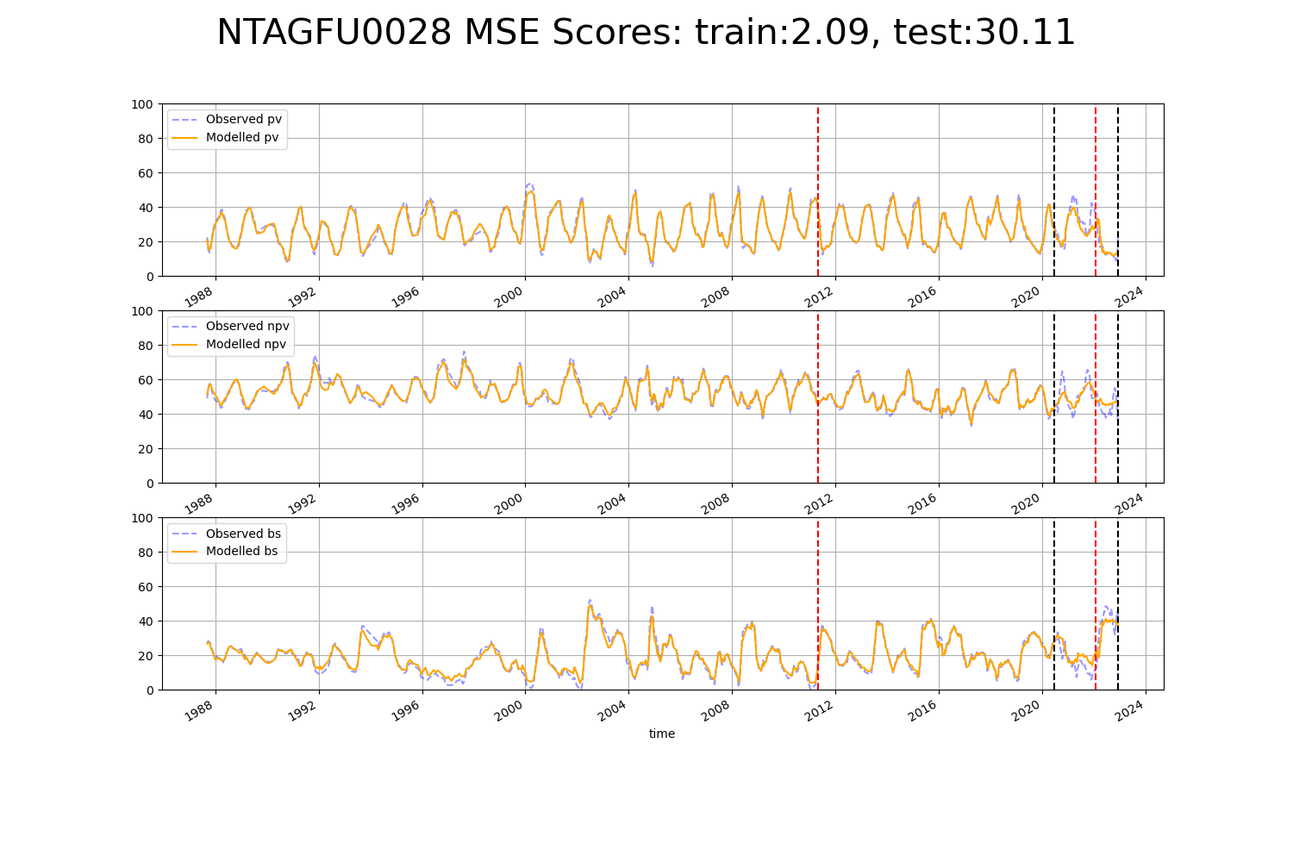

# NTAMGD0003

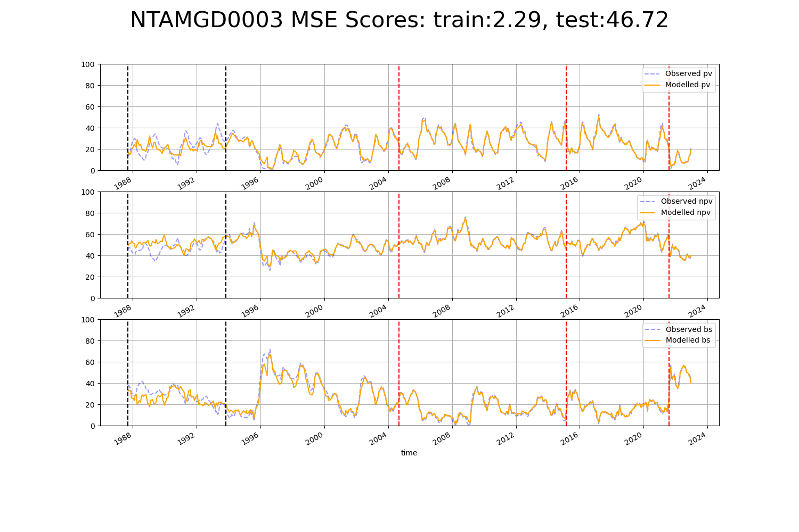

# NTASSD0001

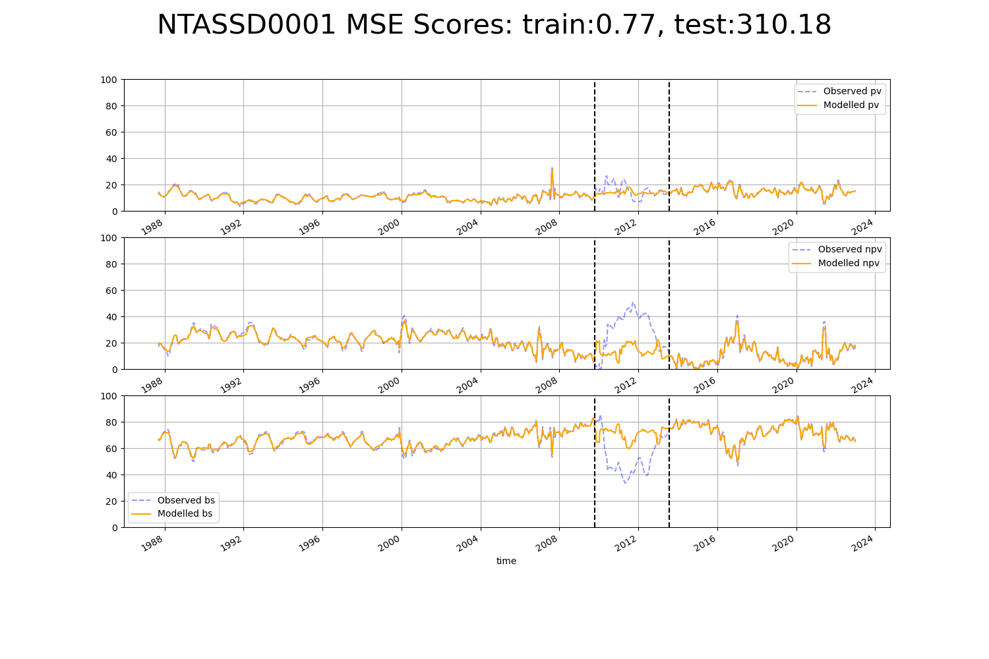

# NTATAN0003

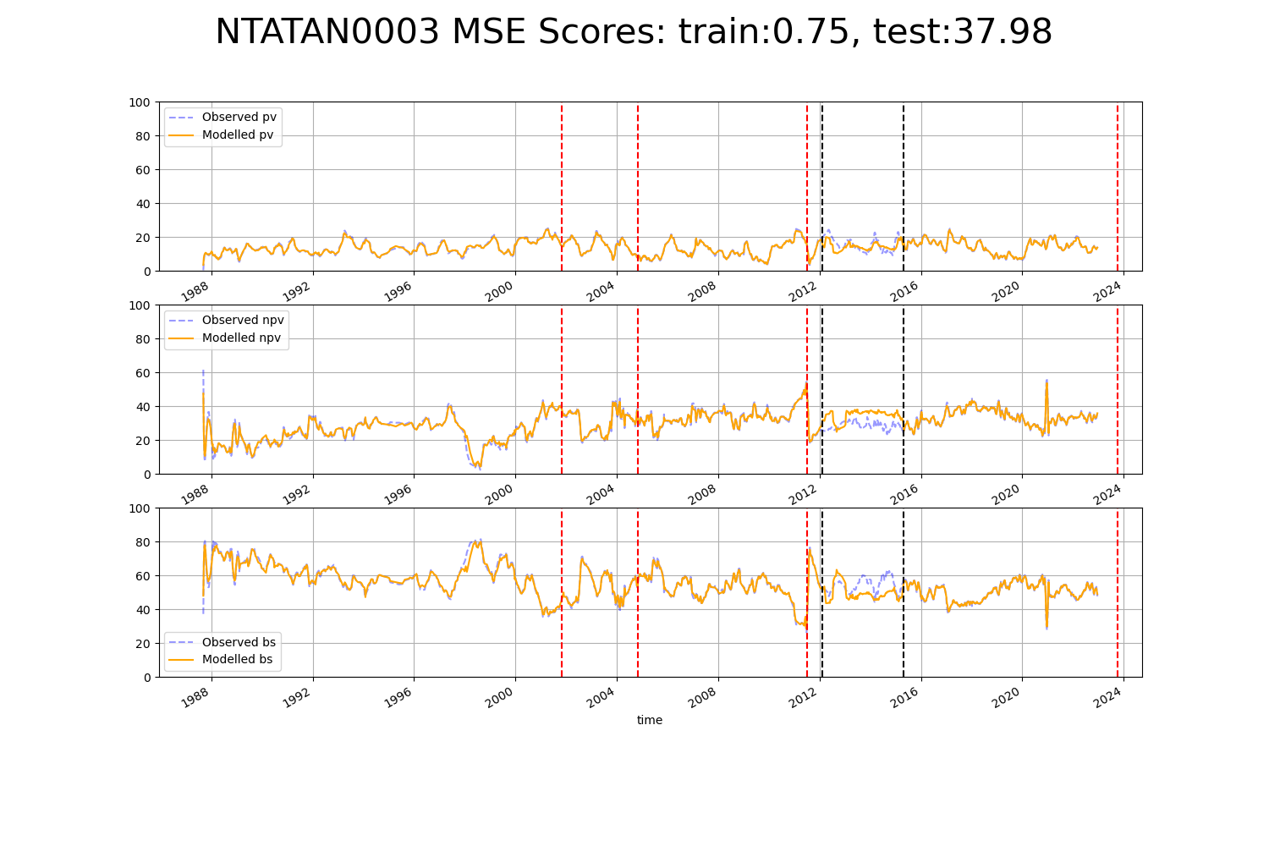

# NTATAN0004

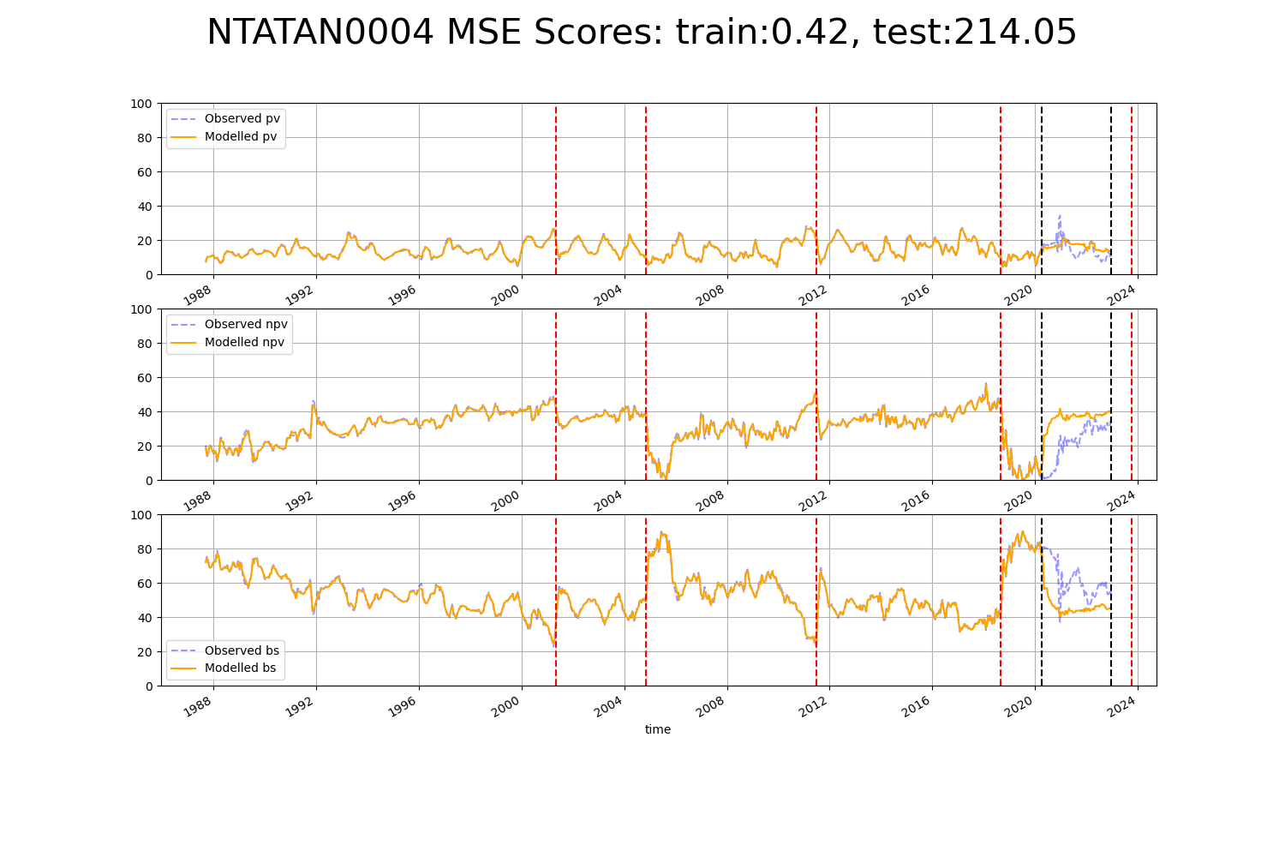

# QDASSD0001

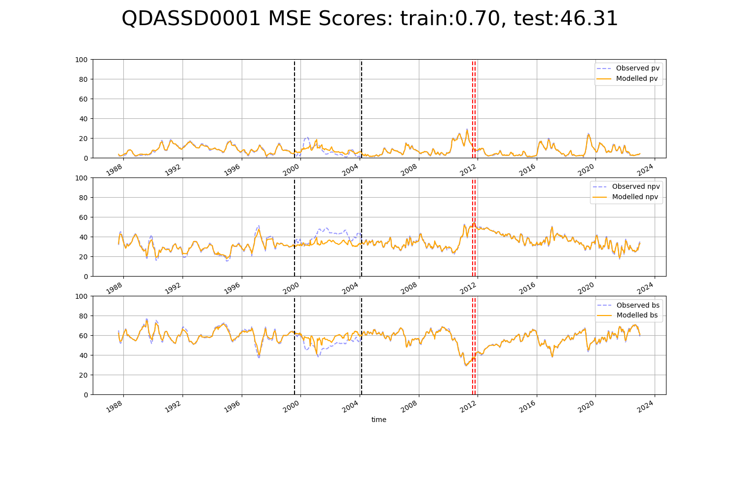

# QDASSD0002

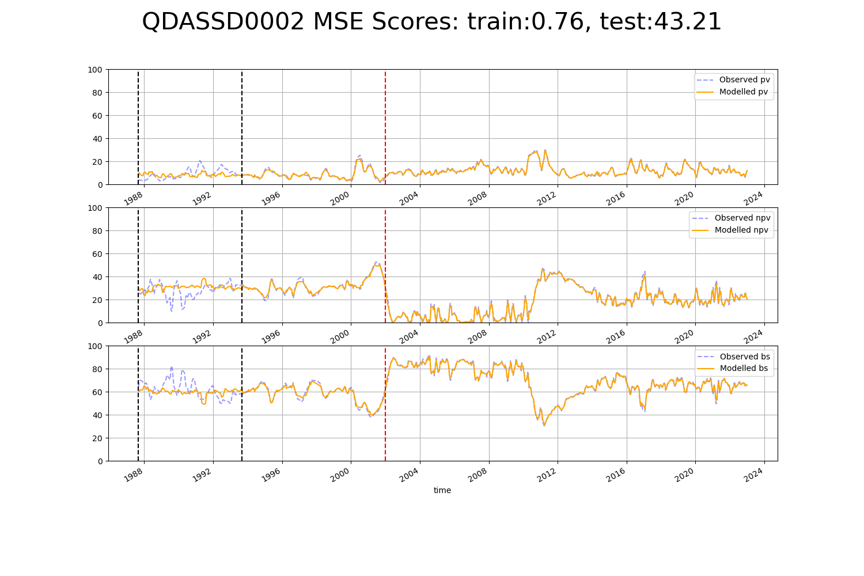

# QDASSD0004

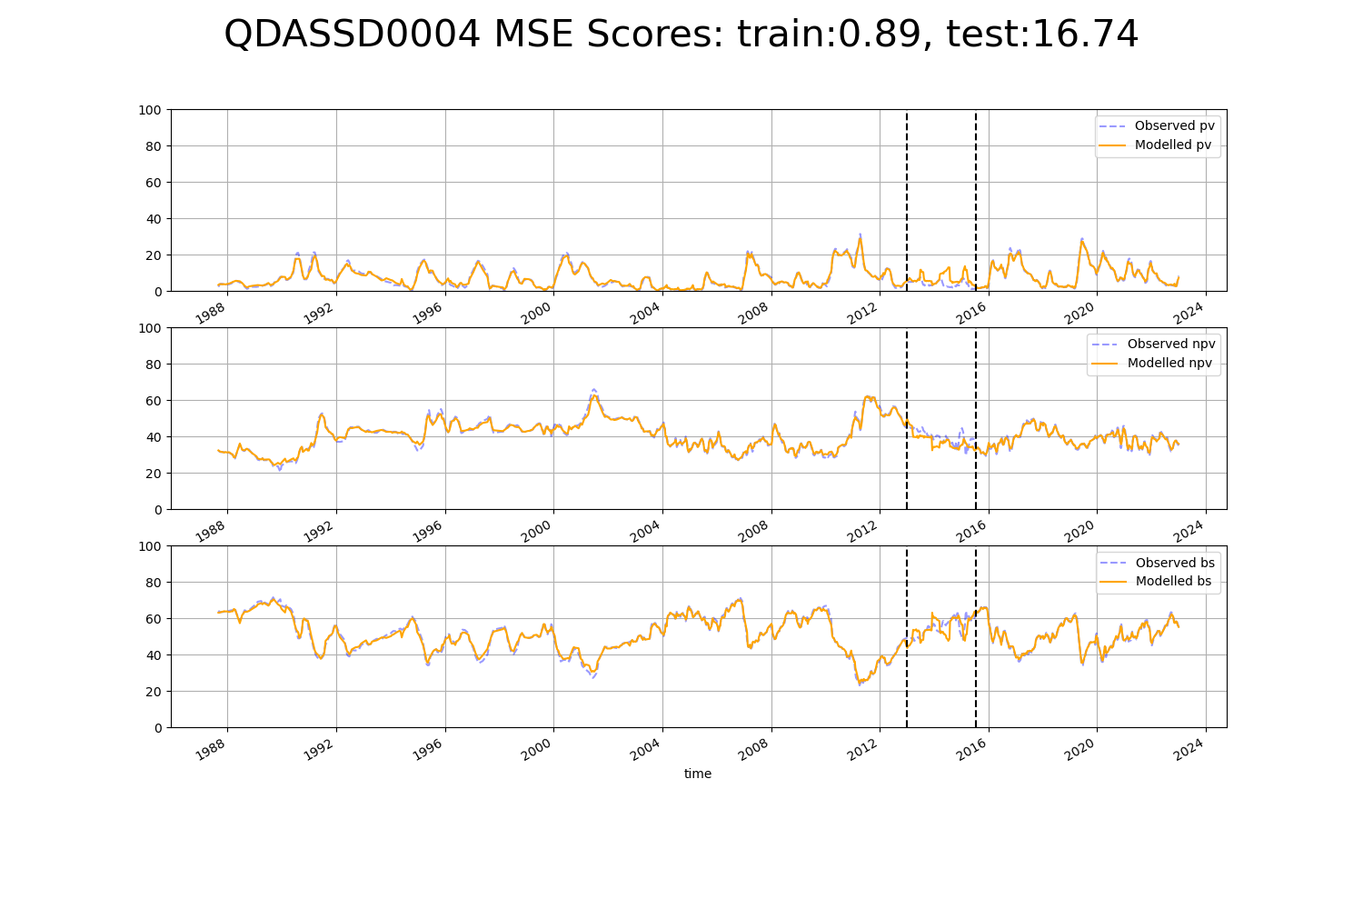

# QDASSD0008

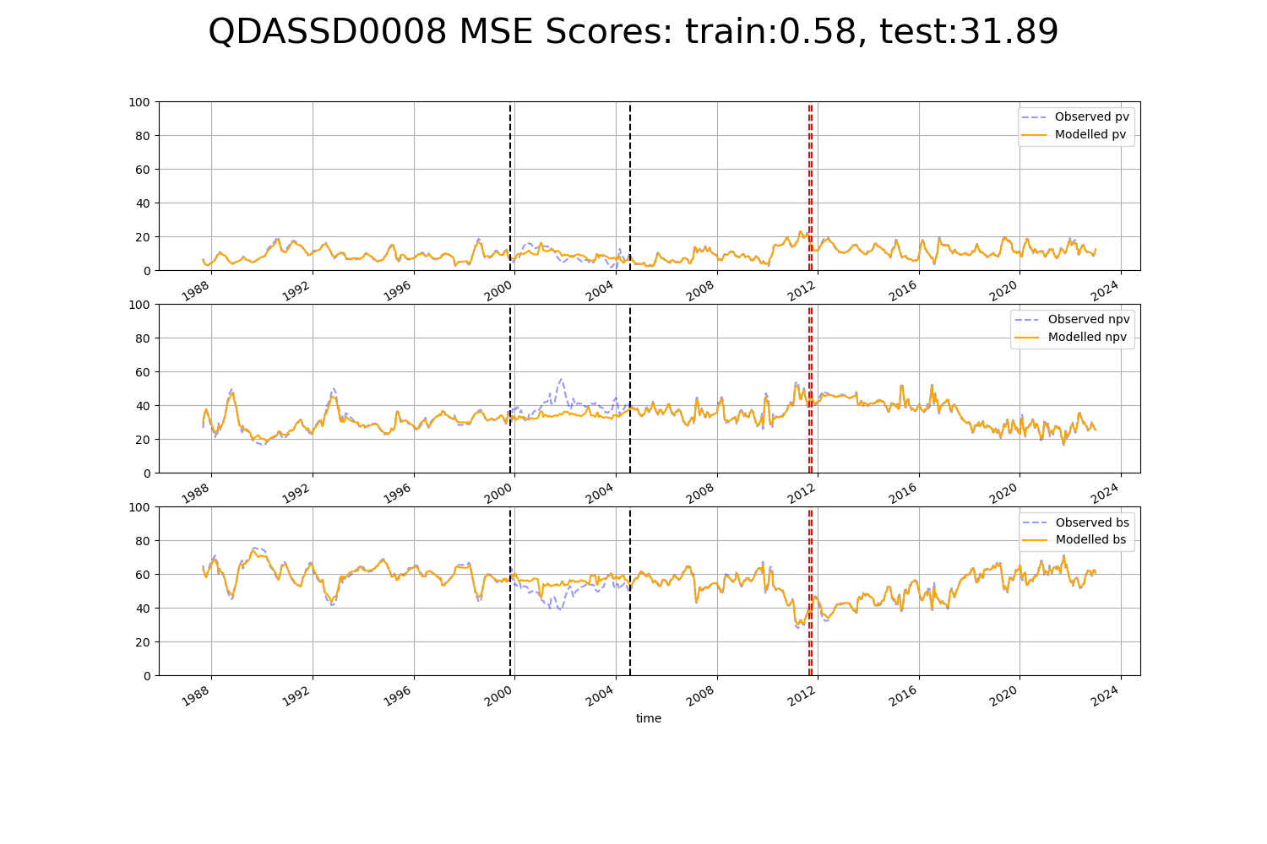

# SATFLB0008

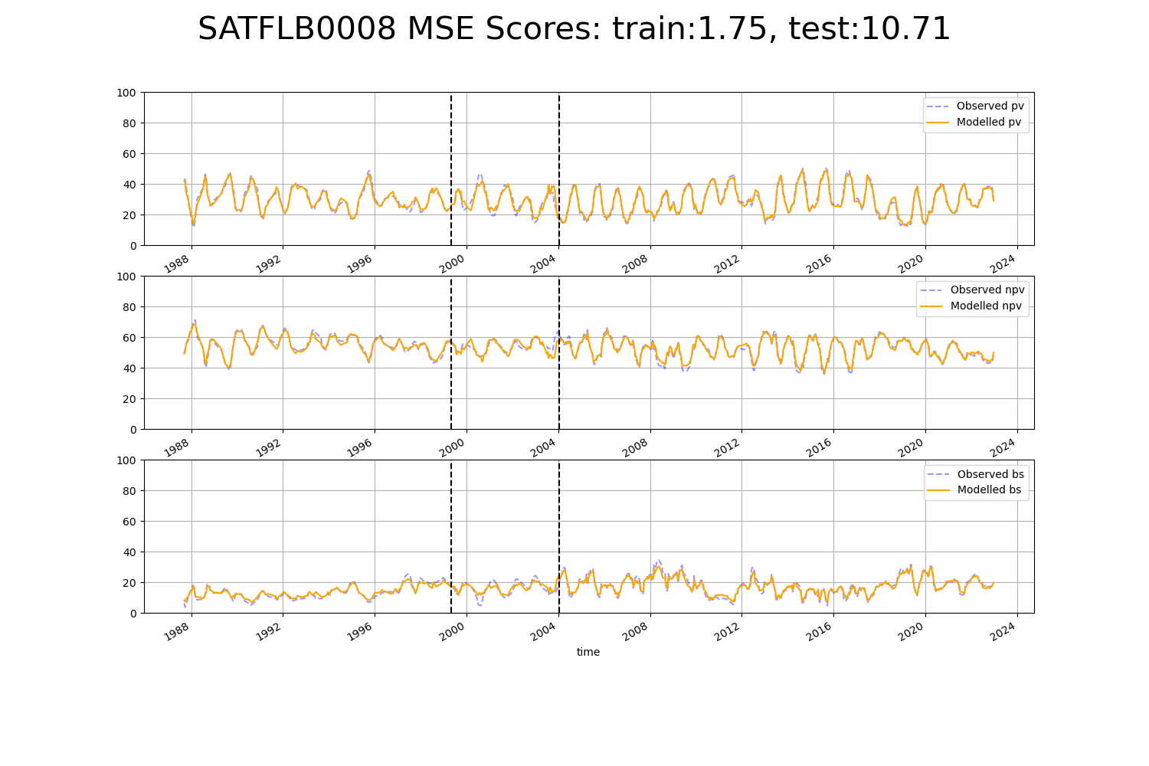

# SATFLB0018

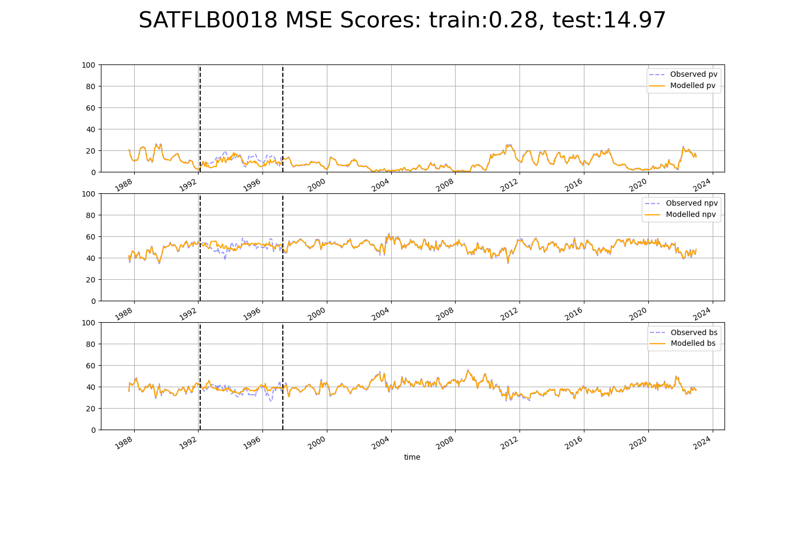

# SATFLB0019

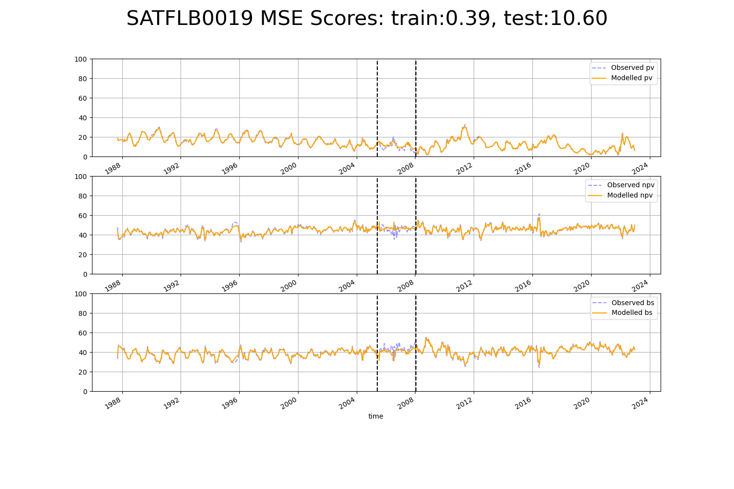

# SATFLB0021

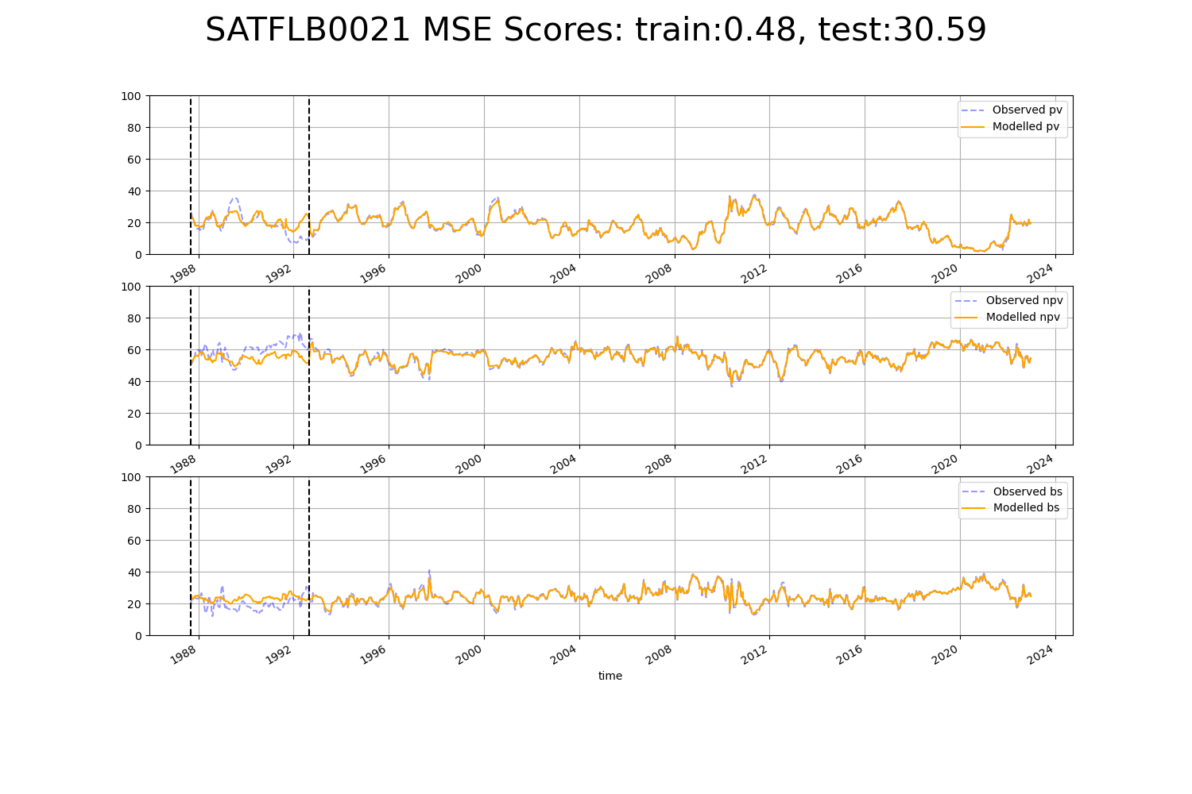

# WAACEK0003

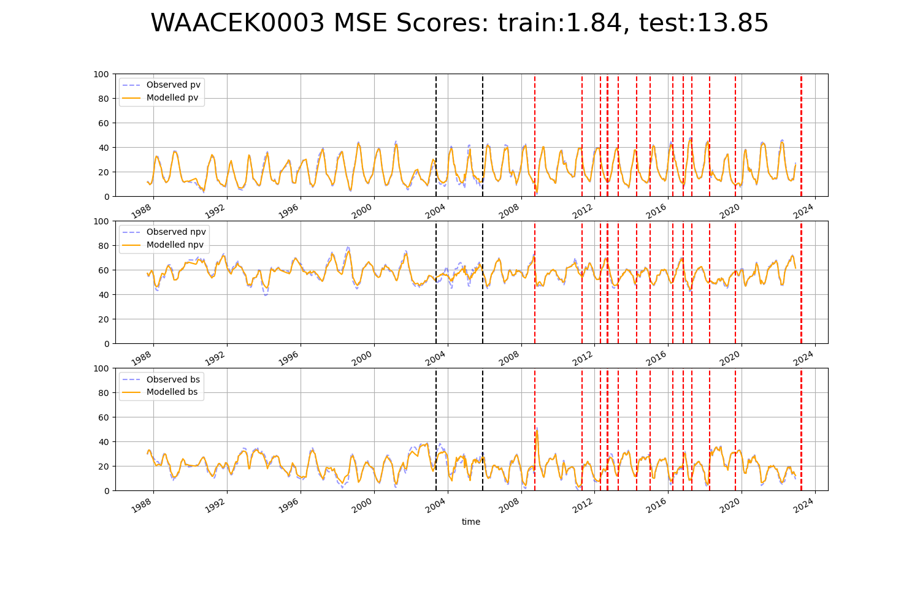

# WAACOO0031

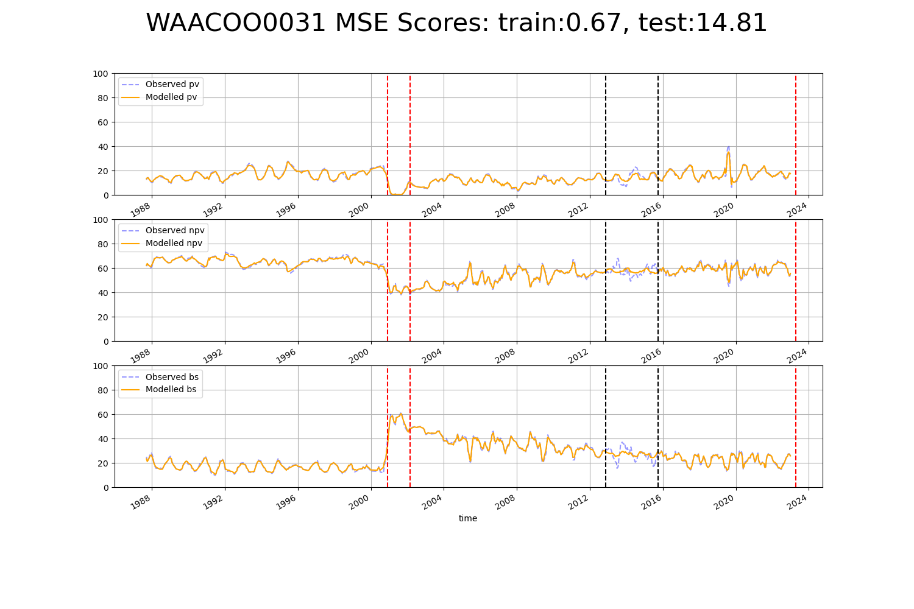

# WAACOO0032

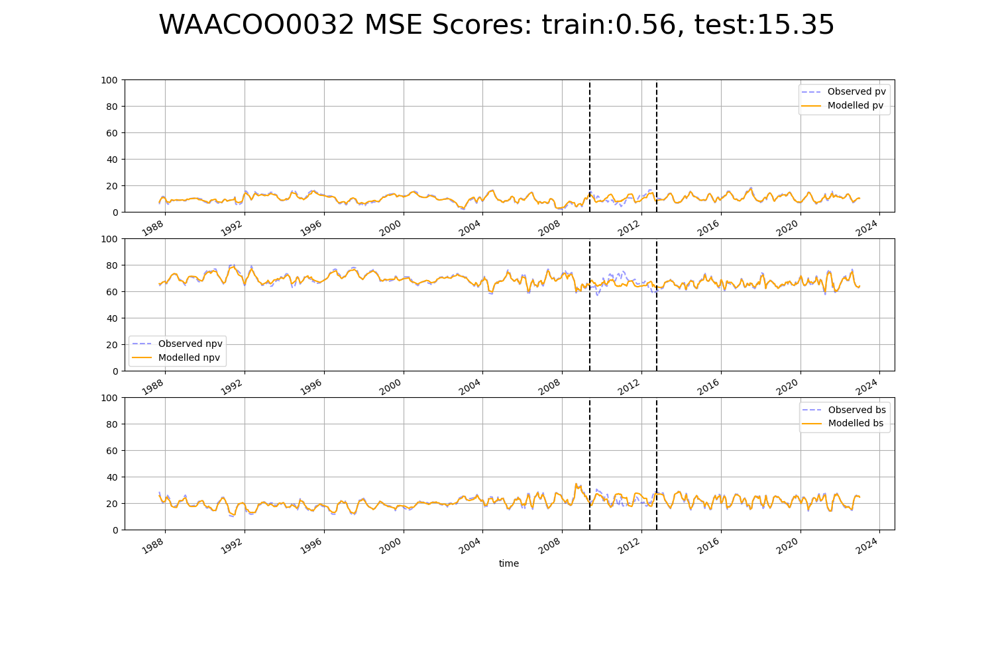

# WAAGSD0001

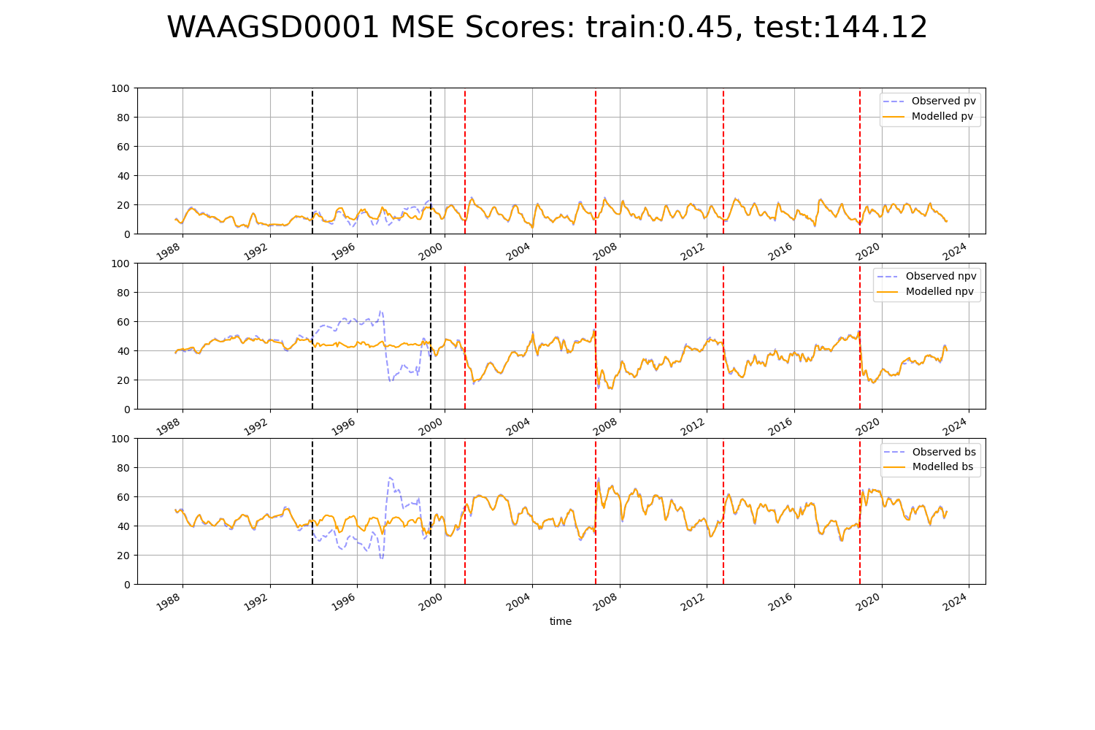

# WAALSD0003

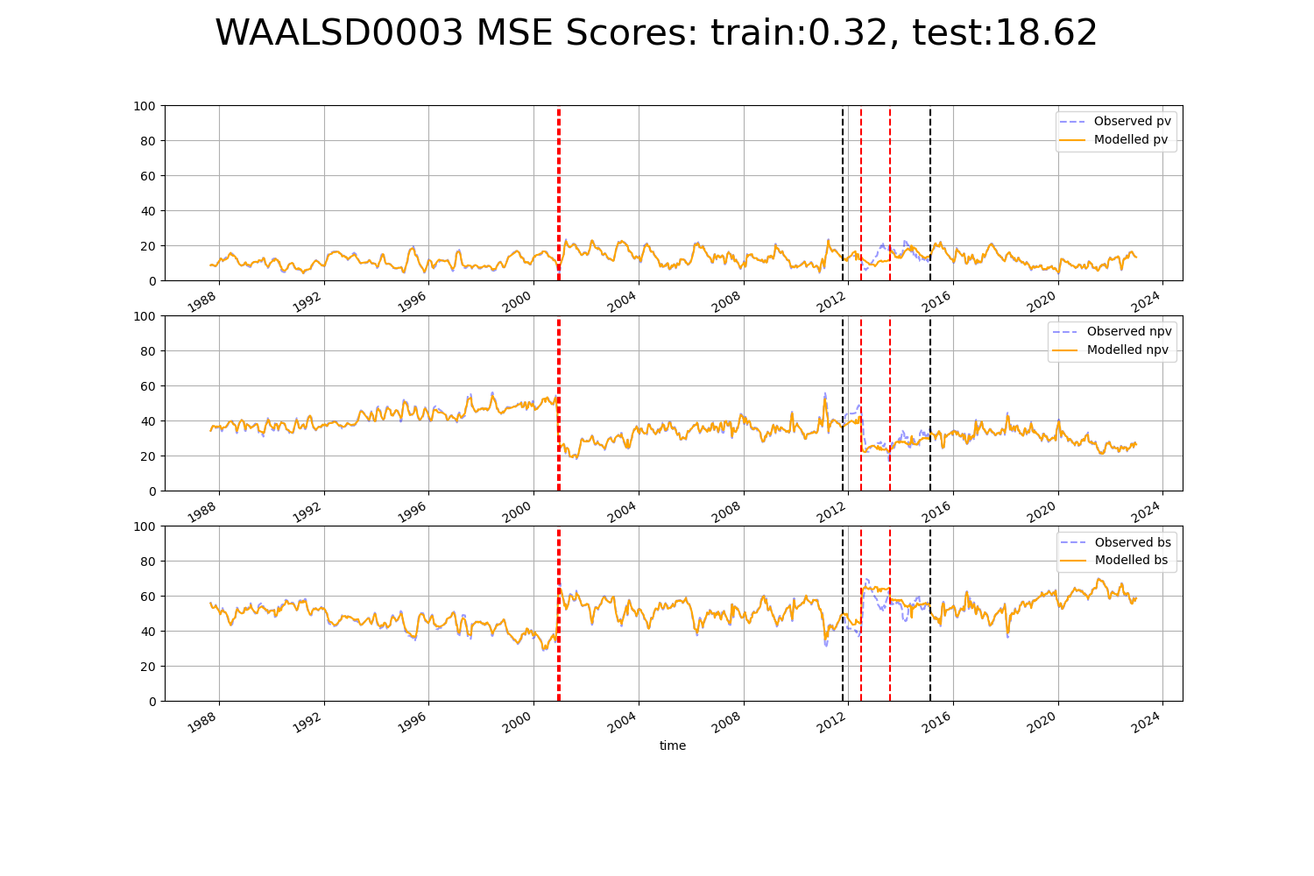

# WAAMUR0001

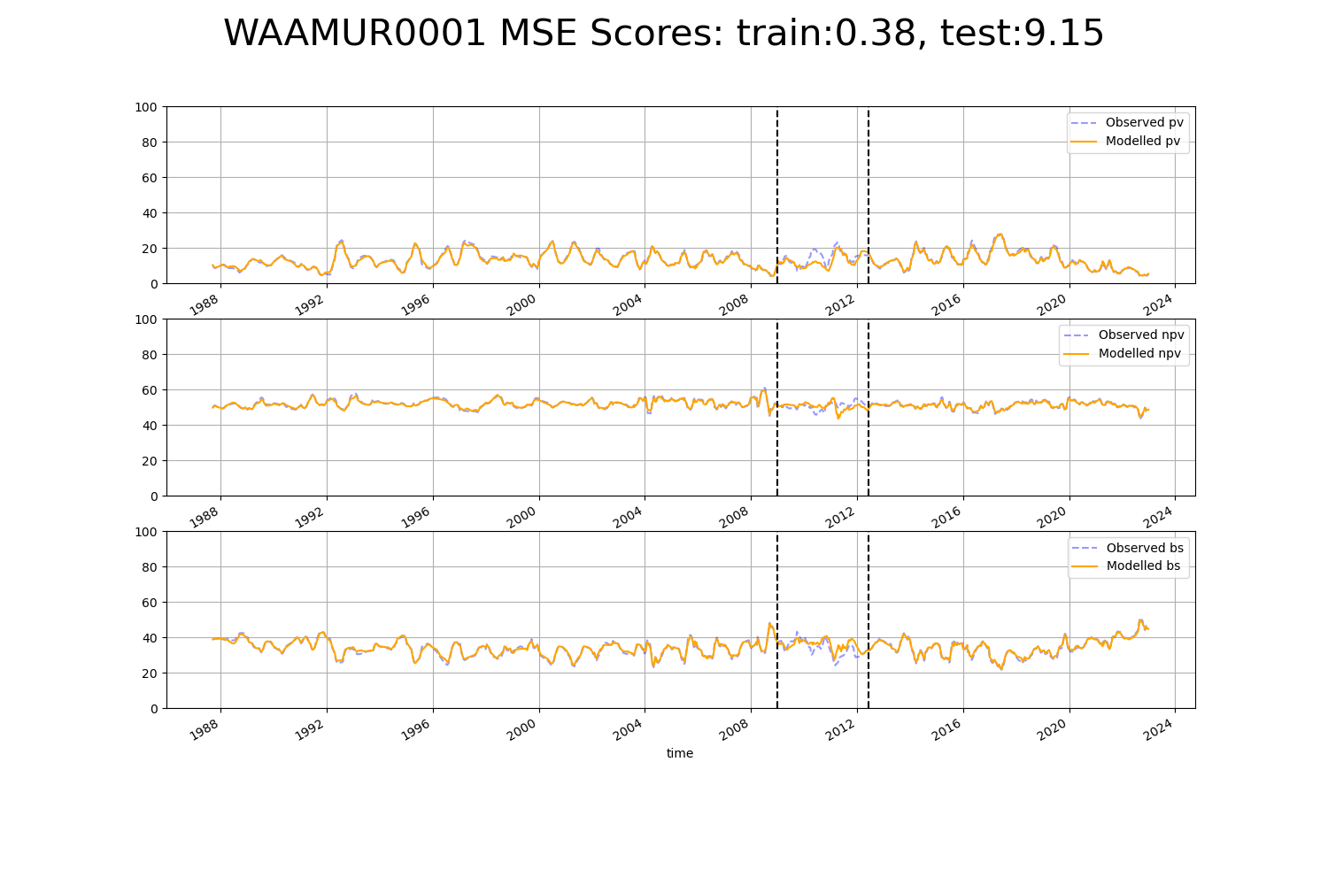

# WAAMUR0002

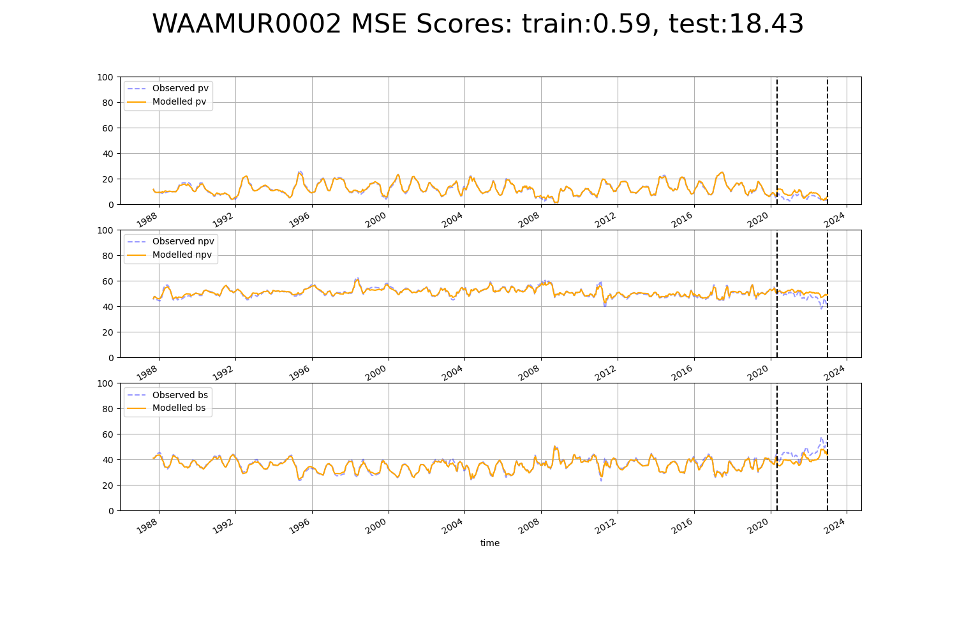

# WAAMUR0028

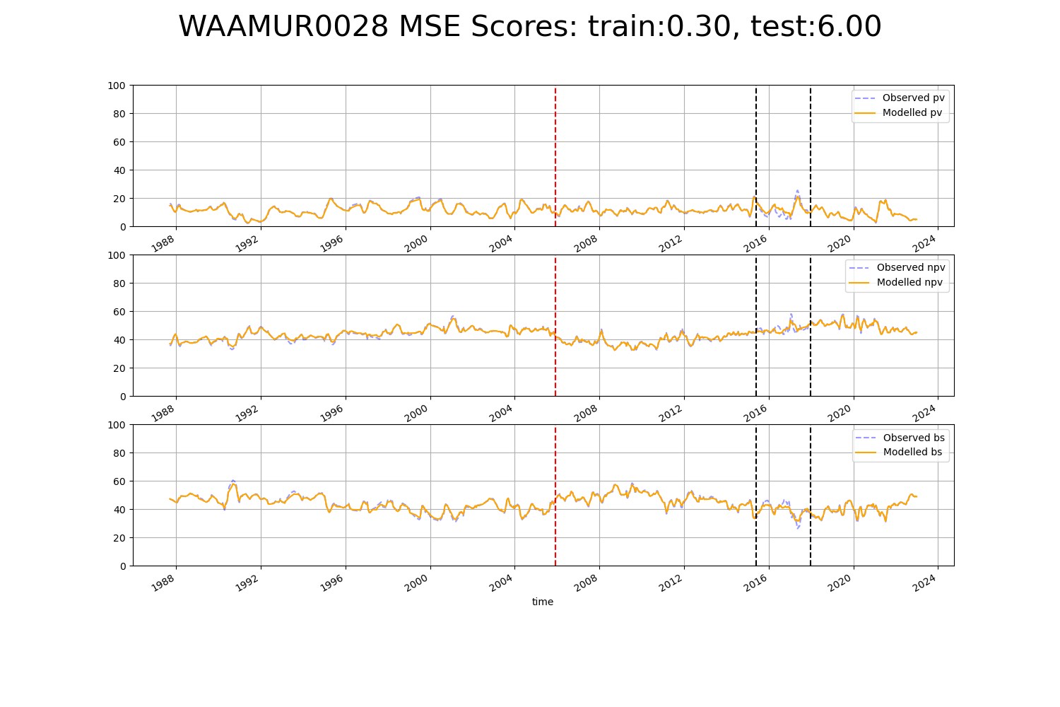

# WAAMUR0029

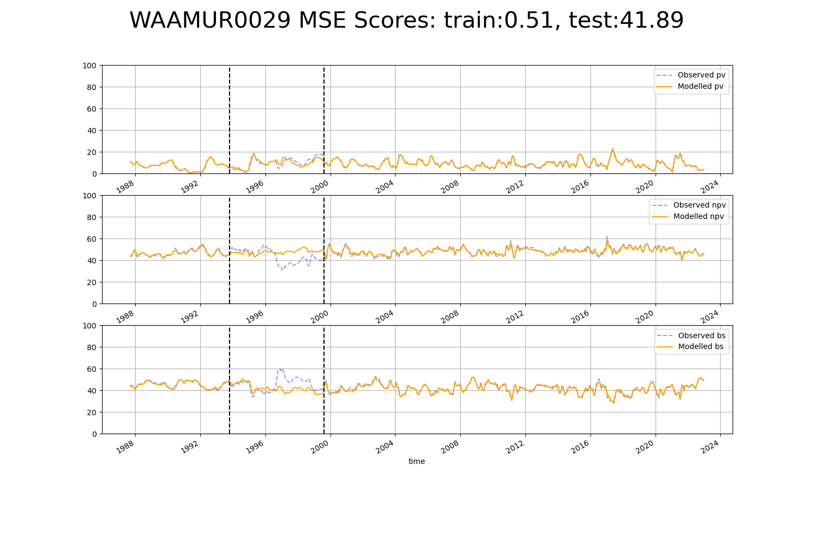

# WAAMUR0030

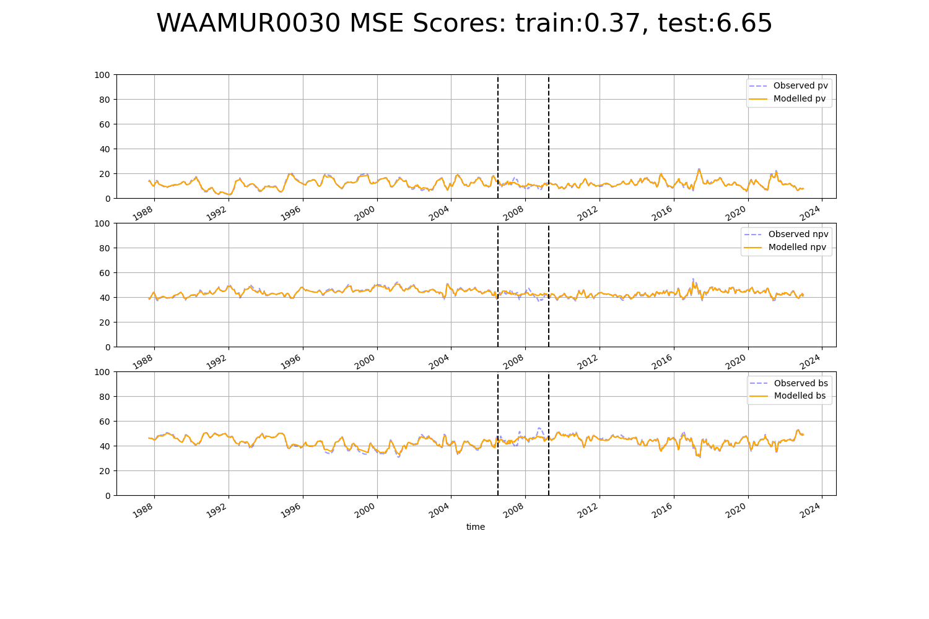

# WAAMUR0031

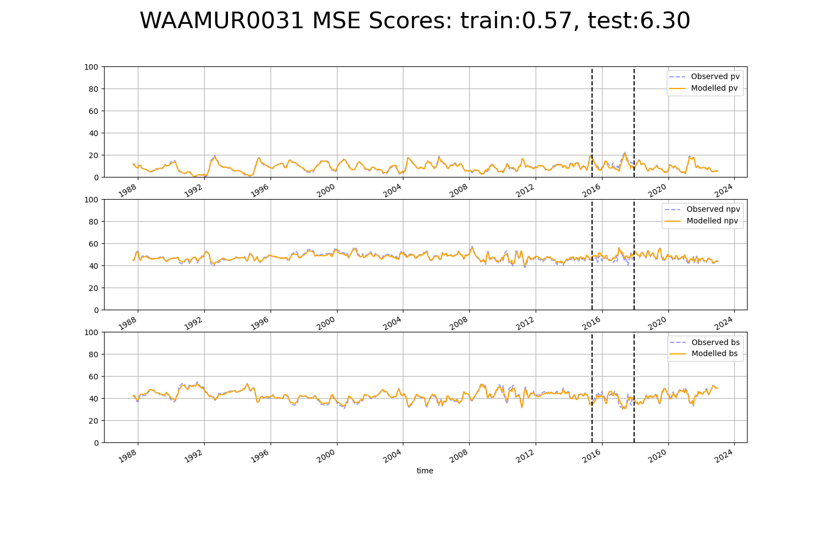

# WAAPIL0002

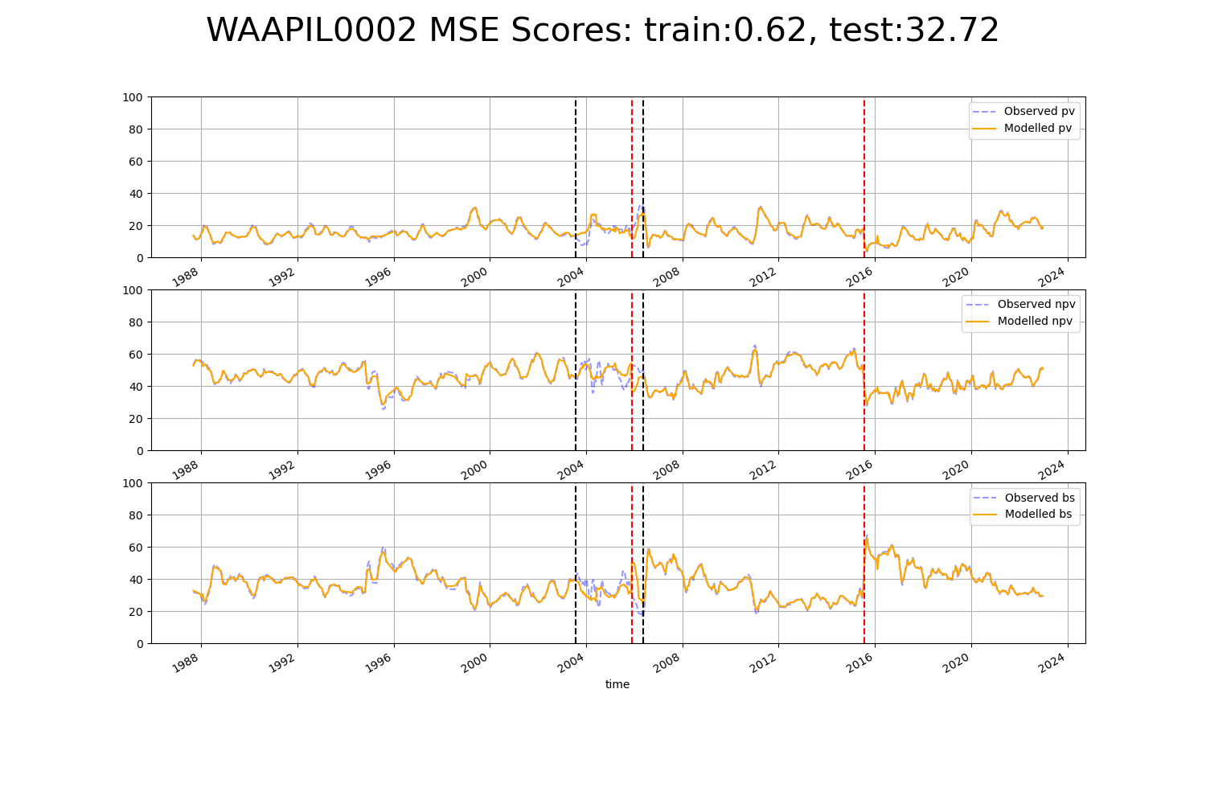

# WAAPIL0003

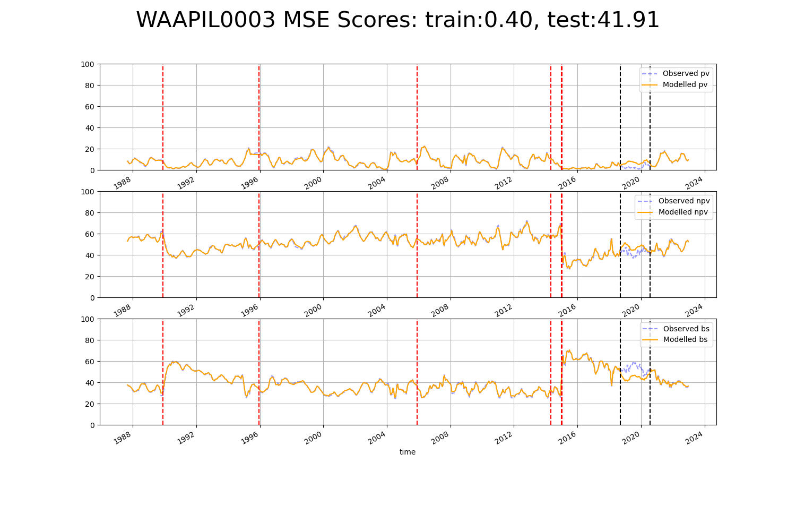

# WAAPIL0006

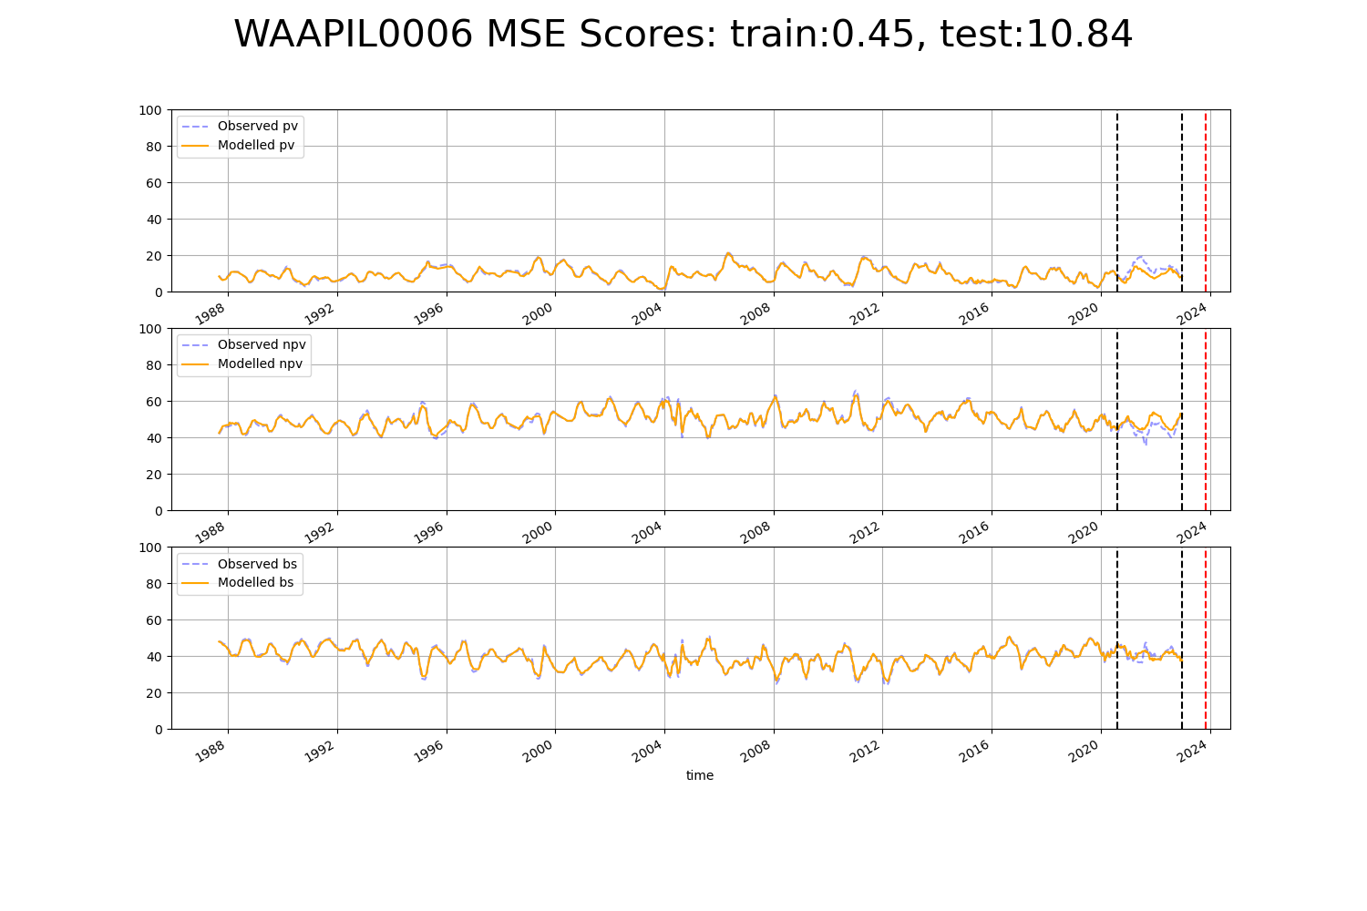

# WAAPIL0012

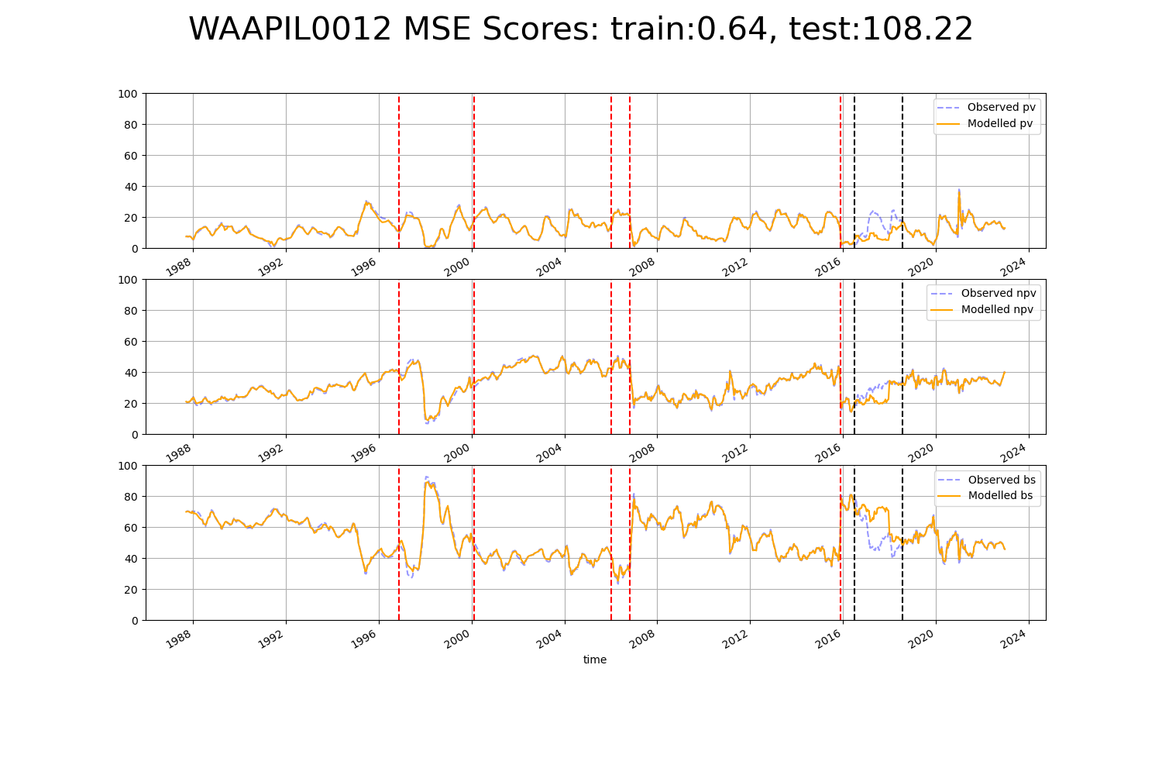

# WAAPIL0013

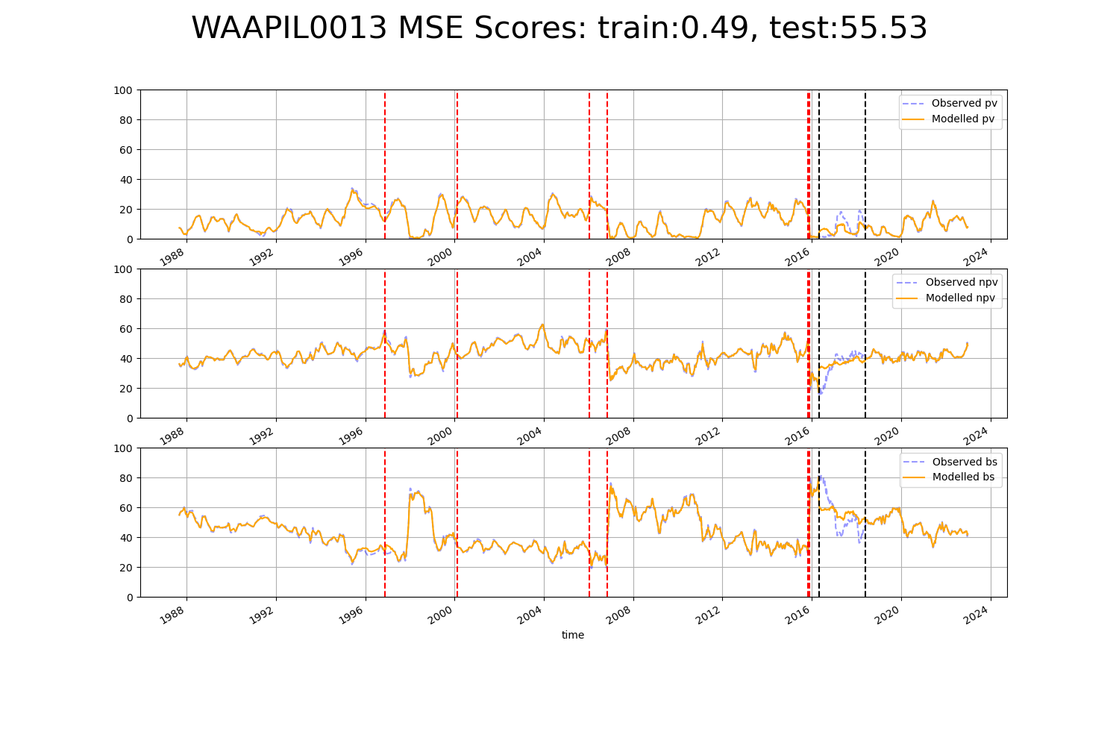

# WAAPIL0017

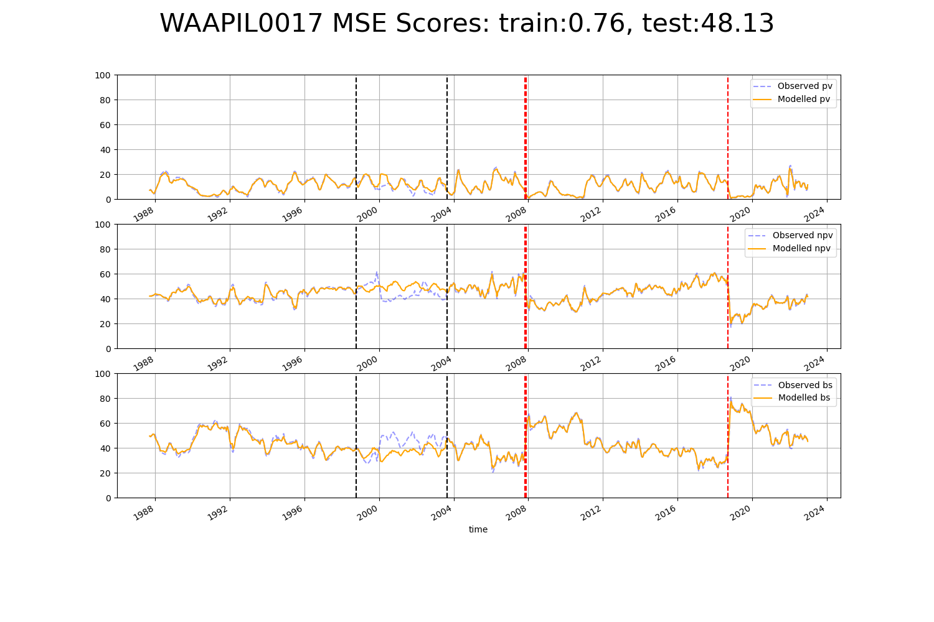

# WAAPIL0020

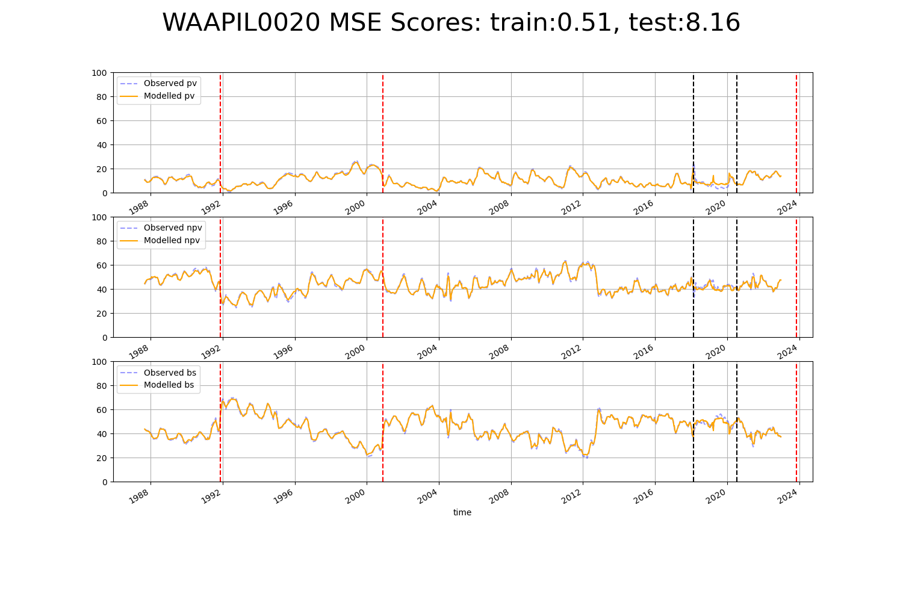

# WAAPIL0027

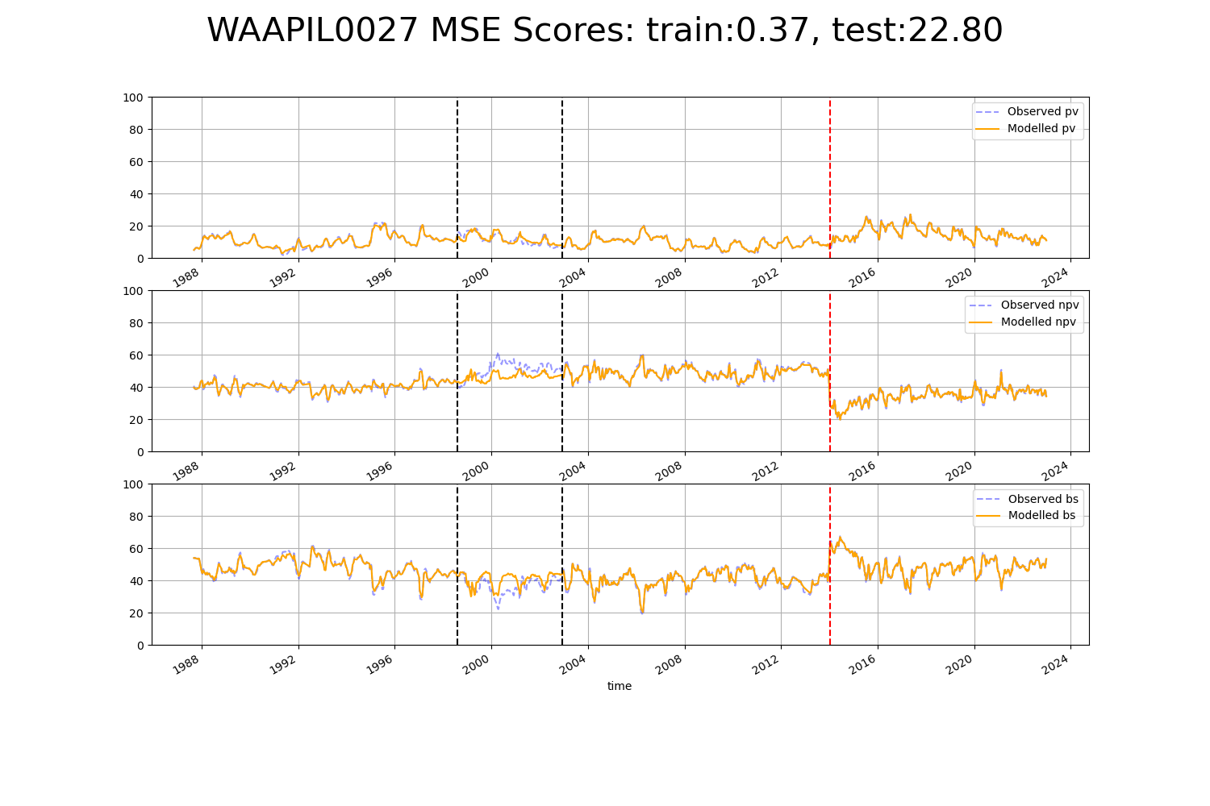

# WAAPIL0031

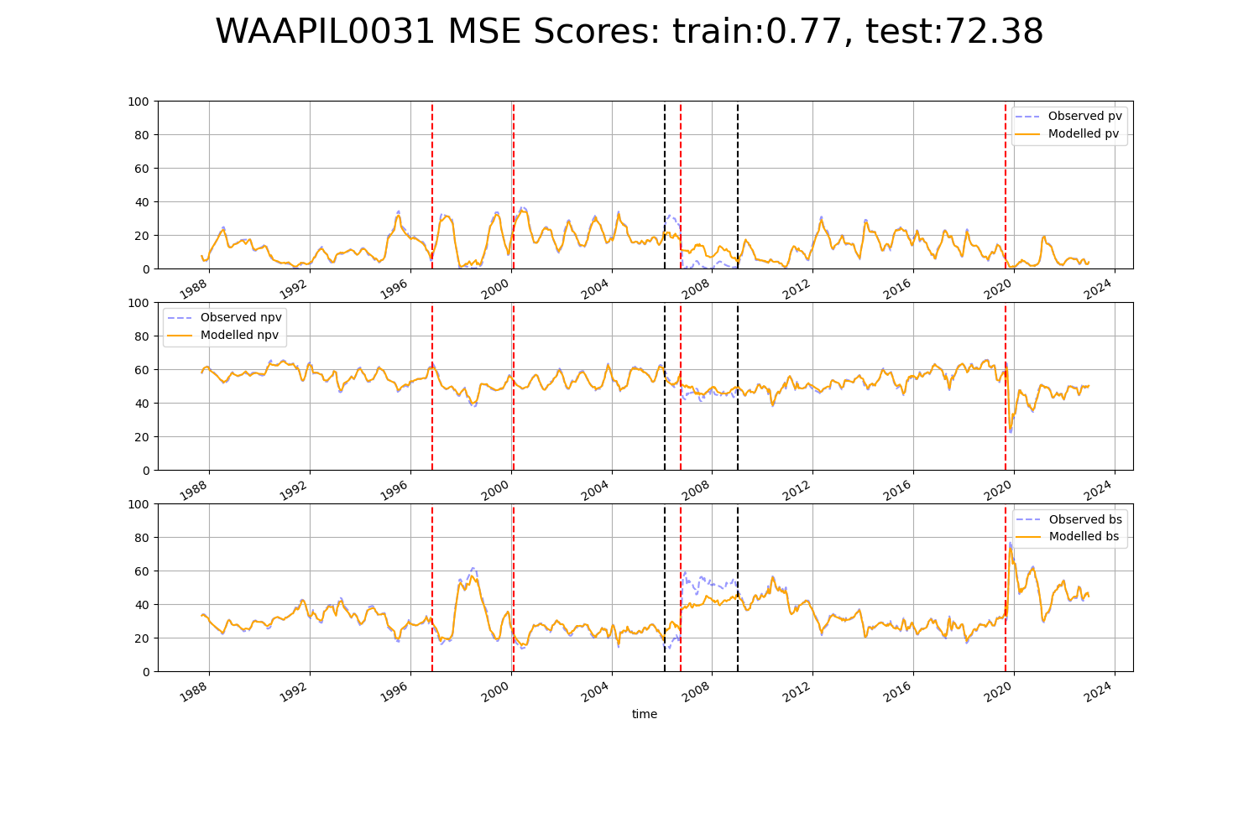

# WAAPIL0034

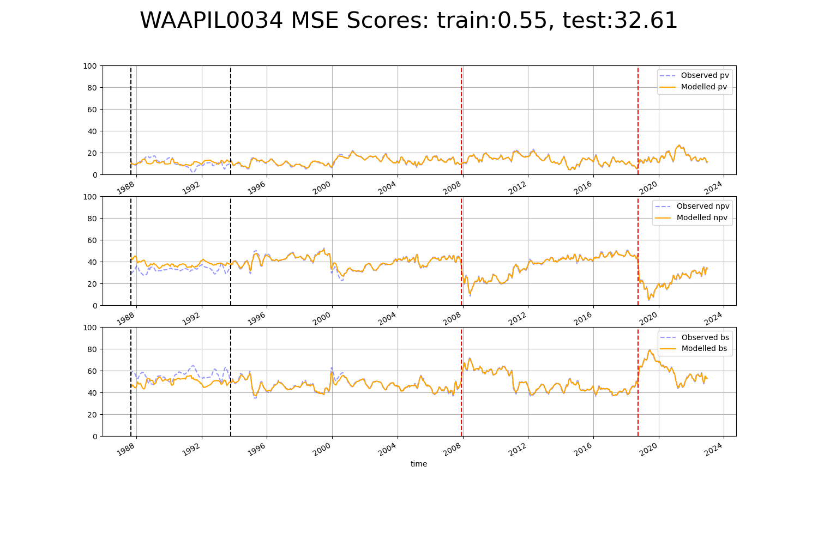

# WAAPIL0035

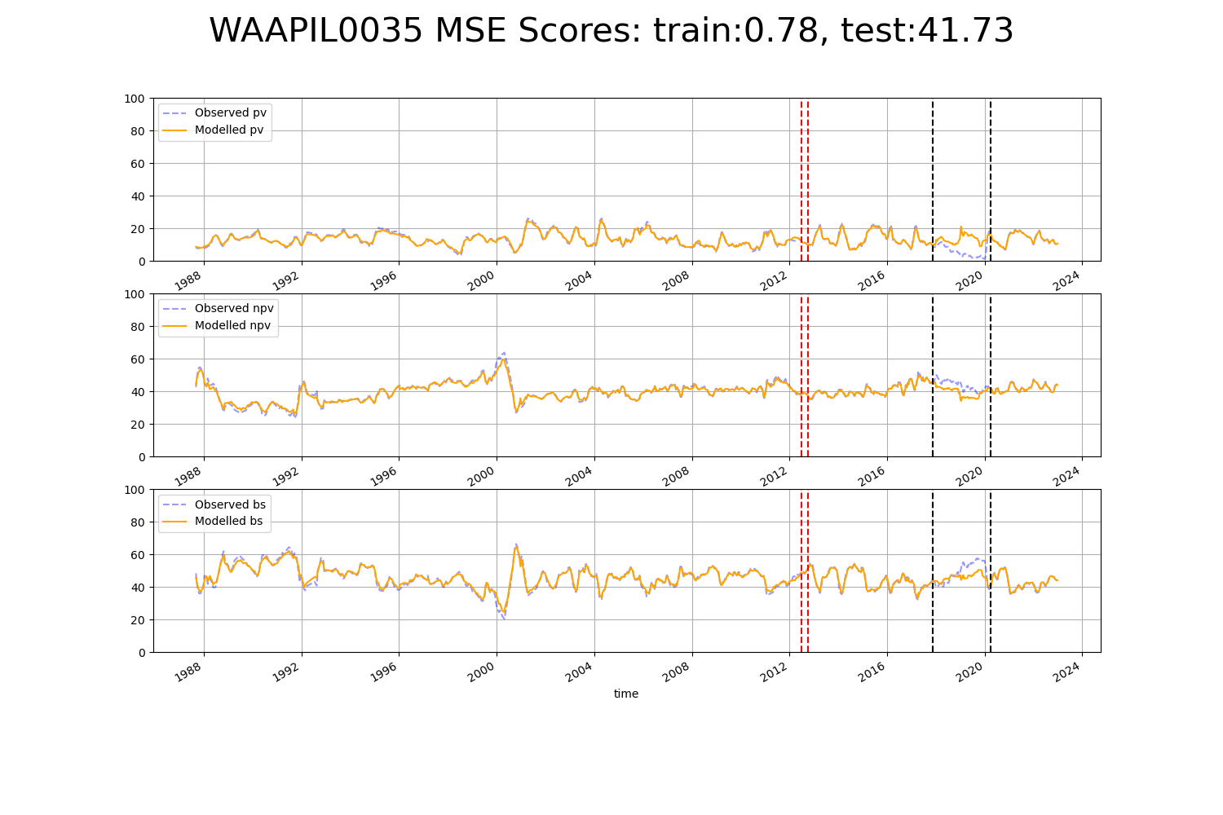

# WAAVIB0002

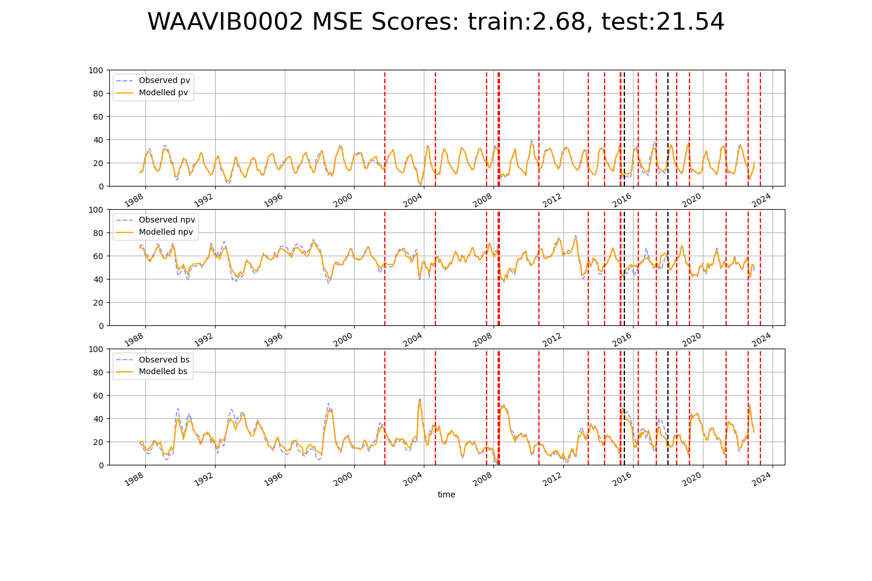

# WAGCOO0002

